GRADE 12 - CBSE

COMPUTER SCIENCE

PROJECT

ON

SHOPPING MALL

USING

PYTHON PROGRAMMING LANGUAGE

DONE BY – PRATITI, MITHUL & AMIT

logo qatargas small

**BONAFIDE CERTIFICATE**

This is to certify that Master Amitkumar Patel has completed his project work entitled, “The Elite Mall” as a part of the paper of Computer Science, under my guidance and supervision in the Department of Computer Science. To the best of my knowledge, it is an original piece of his work. It is worthy of consideration in partial fulfilment of the requirement of CBSE, Delhi for the All India Senior Secondary Examination in the subject Computer Science.

**Name of the guide: Principal**

**Mrs. Bharati Patel Mr. Arogya Reddy**

**(Signature) (Signature)**

**External Examiner**

**(Signature)**

logo qatargas small

**BONAFIDE CERTIFICATE**

This is to certify that Master Mithul Titten Koshy has completed his project work entitled, “The Elite Mall” as a part of the paper of Computer Science, under my guidance and supervision in the Department of Computer Science. To the best of my knowledge, it is an original piece of his work. It is worthy of consideration in partial fulfilment of the requirement of CBSE, Delhi for the All India Senior Secondary Examination in the subject Computer Science.

**Name of the guide: Principal**

**Mrs. Bharati Patel Mr. Arogya Reddy**

**(Signature) (Signature)**

**External Examiner**

**(Signature)**

logo qatargas small

**BONAFIDE CERTIFICATE**

This is to certify that Ms. Pratiti Solanki has completed her project work entitled, “The Elite Mall” as a part of the paper of Computer Science, under my guidance and supervision in the Department of Computer Science. To the best of my knowledge, it is an original piece of her work. It is worthy of consideration in partial fulfilment of the requirement of CBSE, Delhi for the All India Senior Secondary Examination in the subject Computer Science.

**Name of the guide: Principal**

**Mrs. Bharati Patel Mr. Arogya Reddy**

**(Signature) (Signature)**

**External Examiner**

**(Signature)**

logo qatargas small

**ACKNOWLEDGEMENT**

I would like to express my sincere gratitude to my computer science teacher Mrs. Bharati Patel for her constant guidance, support and for lending a helping hand , without which this project would not have come forth.

Moreover, I would like to thank my parents for their encouragement in completing this project and my teammates for playing a crucial role at every step of the project.

**TABLE OF CONTENTS**

1. Acknowledgement
2. Overview of Python
3. Synopsis
4. Requirements and Instructions
5. Flowcharts
6. Modules
7. Functions and Classes
8. Source code
9. Output
10. Shortcomings
11. Bibliography

**Overview of Python**

**Python** is a widely used general-purpose, high-level programming language.Its design philosophy emphasizes code readability, and its syntax allows programmers to express concepts in fewer lines of code than would be possible in languages such as C++ or Java. The language provides constructs intended to enable clear programs on both a small and large scale.

Python supports multiple programming paradigms, including object-oriented, imperative and functional programming orprocedural styles. It features a dynamic type system and automatic memory management and has a large and comprehensive standard library.

This project is a Python program on a Shopping Mall. Shopping malls all around the globe provide people facilities such as groceries, gaming zones, foodcourts and exhibitions. This program aims to stimulate the above mentioned characteristics of a shopping mall and demonstrates the current scenario of online shopping and arcade games.

**Synopsis**

The Elite Mall is a program that imitates the function of a basic shopping Mall and more. The Mall has various shops and hubs:

* **CES 2014**
* **CUSTOMER SERVICE**
* **FOODCOURT**
* **FIFA 2014**
* **ATM**
* **SPLASH**
* **GROCERY**
* **GAMEZONE**

Each place and Hub has its own function.

The program is the future of shopping online. In the future when you want to experience shopping and all the joys that come along with it someone could simply open up the program of the Shopping Mall and buy and discard items and it could be delivered directly to your house

**Hardware and Software Requirements**

* Windows 2000 to Windows 8
* 32-bit Operating System
* Minimum 256MB RAM
* Python Version 2.7
* Keyboard, mouse and monitor
* Processor : minimum Pentium 4, 1Ghz single core
* Compact Disc Drive

**INSTRUCTIONS**

* Insert the CD
* Open file in Python
* Run the program

Modules

**Pygame:**

Pygame is a cross-platform set of Python modules designed for writing video games. It includes computer graphics and sound libraries designed to be used with the Python programming language. It is imported by **import pygame statement.**

**Math:**

The [math](http://pymotw.com/2/math/#module-math) module implements many of the IEEE functions that would normally be found in the native platform Python libraries for complex mathematical operations using floating point values, including logarithms and trigonometric operations. It is imported by **import math statement.**

**Decimal :**

The [decimal](http://pymotw.com/2/decimal/#module-decimal) module implements fixed and floating point arithmetic using the model familiar to most people, rather than the IEEE floating point version implemented by most computer hardware.

**Datetime:**

[Datetime](http://pymotw.com/2/datetime/#module-datetime) contains functions and classes for working with dates and times, separately and together. It is imported by **import datetime** statement.

**Random:**

The [random](http://pymotw.com/2/random/#module-random) module provides a fast pseudorandom number generator based on the Mersenne Twister algorithm.

**Turtle:**

Turtle graphics is a popular way for introducing programming to kids. It was part of the original Logo programming language developed by Wally Feurzig and Seymour Papert in 1966.

**Os :**

This module provides a unified interface to a number of operating system functions.

FUNCTIONS AND CLASSES

1. **mario :**  Function that creates the main player Mario.
2. **grocerymario**  **:**  Function for Grocery Store player
3. **fifacornermario :**  Function for FIFA 2014 Mario character
4. **guessinggame :**  Function containing the game ‘Guessing Game’.
5. **foodcourt :**  Function handles the FOODCOURT restaurants.
6. **McDonalds :**  Function containing McDonalds restaurant menu and billing.
7. **KFC :**  Function containing McDonalds restaurant menu and billing.
8. **grocery :**  Function handling grocery store proceedings.
9. **otherwise :**  Function within grocery() which is executed if the user wants to add or remove more items to the grocery bucket.
10. **Produce :**  Function containing produce items and gathers purchase information.
11. **Meat :** Function containing meat items and gathers purchase information.
12. **Dairy :** Function containing dairy items and gathers purchase information.
13. **seafood :** Function containing seafood items and gathers purchase information.
14. **guestservice :**  Function within grocery() which contains purchase and billing code.
15. **ATM :**  Function containing code for displaying ATM pictures on the pygame window and to call ATM2() when the user wants to perform ATM functions.
16. **ATM2 :**  Function that contains code necessary for performing transactions, checking balance and and depositing credit.
17. **FIFA :** function which contains code to display pictures on the pygame window and call functions according to the user's request.
18. **FIFACORNER :**  Function containing FIFA 2014 game and quiz.
19. **XNO :**  Function containing code for running the XNO game.
20. **Wordsearch :**  Functioning containing code for running the Wordsearch game.
21. **Gamezone :**  Function that handles the different games in the GAMEZONE of The Elite Mall.
22. **COMSERV :** Function COMSERV having code necessary to display Customer Service section pictures and graphics.
23. **customerservice :** Function containing customer service section of the mall. It contains features like feedback provision, filing complaints and offers at the various shops of the mall.
24. **CES2014 :** Function containing code for running the Tech Show area.
25. **movi :**Function for displaying video graphics on the pygame window
26. **TECH :** Function containing Tech Information and Snack Counter
27. **game :** Function containing **classes** and has code dedicated for the first level of A-MAZE game in the gamezone.

**Class player**(object):

**Methods:**

__init__(self):

move(self,X,Y):

move_single_axis(self,X,Y):

**Class enemyplayer**(object):

**Methods :**

__init__(self,enemyX,enemyY):

moveenemy(self,X1,Y1):

killed(self,X1,Y1):

**Class Wall**(object):

**Methods :**

__init__(self,w,x,y,z):

**Class Enemy**(object):

**Methods :**

__init__(self,w,x,y,z):

1. **Game2 :** Function containing **classes** and has code dedicated for the second level of A-MAZE game in the gamezone.

**Class player**(object):

**Methods :**

__init__(self):

move(self,X,Y):

move_single_axis(self,X,Y):

**Class enemyplayerbullet**(object):

**Methods :**

__init__(self,enemyX,enemyY):

moveenemybullet(self,X11,Y11):

killed(self,X11,Y11):

**Class enemyplayer**(object):

**Methods :**

__init__(self,enemyX,enemyY):

moveenemy(self,X1,Y1):

killed(self,X1,Y1):

**Class Wall**(object):

**Methods :**

__init__(self,x,y):

**Class Block**(object):

**Methods :**

__init__(self,x,y)

**Class Enemy**(object):

**Methods :**

__init__(self,w,x,y,z):

1. **Displayscore :** Function to display A-MAZE scores on the pygame window.
2. **VirtualShop :** Function code necessary for displaying graphical information of SPLASH on the pygame window.
3. **BUY :**  Displays message when a clothing item is bought
4. **DISCARD :**  Displays a message when a clothing item is discarded
5. **Clothing :** Function containing BUY() and DISCARD() and code for managing the sequence of appearance of clothing item on the pygame screen.
6. **thebase :** The core function of the entire code which manages the execution of different functions on the basis of player’s position.
7. **malltiming :** Function enclosed in thebase() function to calculate the amount of time spent by the user at The Elite Mall.
8. **startup :** Function that is executed when the program code is first run. It asks the user to input user details and recognizes if the user is an existing one ornot.

**SOURCE CODE**

import pygame,math,decimal #Importing modules

from datetime import datetime

pygame.display.set_caption("---------------------- THE ELITE MALL ---------------------------")

#Caption set for pygame screen

BLACK = ( 0, 0, 0) #Colour codes

WHITE = ( 255, 255, 255)

BLUE = ( 0, 0, 255)

GREEN = ( 0, 255, 0)

RED = ( 255, 0, 0)

PURPLE = ( 255, 0, 255)

WANT = ( 250, 20, 20)

GOLD = ( 255, 165, 0)

SKY = ( 0, 153, 153)

GREY = ( 135, 135, 135)

####################################################################

global pos_x,pos_y,accno,creditcardtype,Mmoney,money,count,l,b,z,score

#Global variables

STARTTIME=datetime.now()

hello = pygame.display.set_mode([800,600]) #Screen display dimensions set

hi=pygame.image.load("mario.png")

groceryplayer=pygame.image.load("grocerystoremario.png")

tata=pygame.image.load("goldenmario.png")

####################################################################

def mario(hi,pos_x, pos_y): #Main player function

hello.blit(hi,[pos_x,pos_y])

####################################################################

def grocerymario(hi,pos_x, pos_y): #Function for Grocery Store player

hello.blit(groceryplayer,[pos_x,pos_y])

####################################################################

1def fifacornermario(tata,pos_x,pos_y): #Function for FIFA 2014 Mario character

hello.blit(tata,[pos_x,pos_y])

####################################################################

global pos_x,pos_y

pos_x = 320

pos_y = 540

x1=10 #Initial values of variables x1 and y1 to be used later on in the program.

y1=10

def guessinggame : # Function Guessing Game

import random,turtle #Importing random and turtle modules

global money

print ""

print "-"*80

print " Welcome to the The Guessing game"

print "-"*80

print ""

print "Rule 1: Guess the number from 1 to 20 to win a megaprize!"

print " "

x=[1,2,3,4,5,6,7,8,9,10,11,12,13,14,15,16,17,18,19,20]

a=random.choice(x) #Returns a random number from the list x.

count=0

for i in range(1,6): #The loop is executed 5 times. The user can try 5 guesses.

print "-"*80

c=" "

while c==" ":

s=input("Guess my number:")

if str(s).isdigit()==False:

print "Enter a number"

else:

c="-"

print "-"*80

if (a==s):

if count==0:

print "You've got the correct answer in",count+1,"tries!"

print

print "CONGRATULATIONS! YOU HAVE WON THE MEGAPRIZE!"

print "YOU GET A MERCEDES BENZ A SERIES"

print "-"*80

claim=input("Press 1 to claim the car:")

if claim==1:

turtle.title("CONGRATULATIONS ON YOUR WIN! (click on the window to close it)") #Executed if the player guesses it right on the first try.

turtle.bgpic("merc.gif")

turtle.pencolor("white")

turtle.pencolor("black")

turtle.exitonclick()

print "It's not over yet! You also get a prize money of Qr.500 for your personal credit card!"

print "-"*80

claim2=input("Press 2 to claim it:")

if claim2==2:

money=money+500

print "Qr.500 has been credit to your card."

print "-"*80

break

else:

print "You've got the correct answer in",count,"tries!"

#Executed if the player gets it right on other tries.

print

print "CONGRATULATIONS! YOU HAVE WON!"

print "YOU GET A TATA NANO!"

print "-"*80

claim=input("Press 1 to claim the car:")

if claim==1:

turtle.pencolor("violet")

turtle.title("CONGRATULATIONS ON YOUR WIN! (click on the window to close it)")

turtle.bgpic("nano.gif")

turtle.pencolor("white")

turtle.exitonclick()

break

else:

count=count+1 #Count incremented if the number guessed is incorrect.

print "HARD LUCK!"

print "You have another",5-i,"tries left!"

if (5-i)>=1: #Checks if the number is very close to the guessed number.

if a-2<s and s<a+2:

print "You're in the hot zone!"

print "You have another",5-i,"tries left!"

if 5-i==0:

print " "

print "POOOOOOR!!! The number I was guessing was :",a

####################################################################

def foodcourt : #Food Court function

global pos_x,pos_y,money,b,x,l,z #Global variables

l={}

b=0

z={}

pos_x=350 #Position reset accordingly.

pos_y=400

def McDonalds : #McDonalds Restaurant function

global z

global money

import turtle as t

print " "

print " Welcome to McDonald's!"

print "-"*80

print

print "We have the following items on the menu:" #Menu card for the restaurant

print ""

print "-"*80

print " ITEM NAME PRICE "

print "-"*80

print "1. Big Mac Qr.15"

print "2. McChicken Qr.20"

print "3. Chicken McNuggets Qr.30"

print "4. McCafe Mango Qr.40"

print "5. McFlurry Qr.10"

print "6. Hot cakes Qr.25"

print "7. World Famous Fries Qr.5"

print "8. Premium Southwest Salad Qr.7"

print "-"*80

print

print "Press 9 to have a look at the items on the menu " #Allows the user to view the items on the menu. Consumer perusal!

print "Press 10 to display your items and get your bill"

print

print "-"*80

print

global b

loop=0

while loop==0:

x=input("Select the item you want to buy:")

#Asks the user to input the choice for buying

d={1:"Big Mac",2:"McChicken",3:"Chicken McNuggets",4:"McCafe Mango",5:"McFlurry",6:"Hot cakes",7:"World Famous Fries",8:"Premium Southwest Salad"}

if x in d.keys :

print "-"*80

g=input("Enter quantity:") #Asks for quantity

print "-"*80

print "Can we confirm your order? (Reply with 'yes' for approval otherwise 'no')" #User's approval

print "-"*80

a=raw_input("")

if a in ["yes","Y","y","YEAH","Yeah","Yup","YES"]:

b=b+15*g

z[d[x]]=g

print

print "This item has been added to your bucket."

if a=="no":

print "Thank you anyways!"

print

if x==9:

loopo=0

print "-"*80

print "Please note: After you are done looking at the items, press 0 to exit"

print "-"*80

while loopo==0:

y=input("Enter your choice :")

if y!=0:

t.setup(width=2000,height=2000,startx=0,starty=0)

t.bgpic(str(y)+".gif")

t.exitonclick()

if y==0:

loopo=0

break

if x==10:

loop=0

while loop==0:

if b>0:

print

print "Your bucket items are:"

print " "

print "-"*80

print "Item","\t"," Quantity"

print "-"*80

for i in z:

print i,'\t',z[i]

print "-"*80

print "Your total bill is Qr.",b

print "-"*80

print "Do we confirm your purchase ?"

d=raw_input("")

if d=="yes":

print "-"*80

print "Thank you for the purchase!","Qr.",b,"has been deducted from your credit card."

money=money-b

print "Your current balance is: Qr.",money

print " "

z={}

e=raw_input("Do you want to exit?")

if e=="yes" or e==”y” or e==”Y”:

loop=1

break

else:

continue

if d=="no" or d==”No” or d==”n”:

print "Thank you anyways!"

print " "

e=raw_input("Do you want to exit?")

if e=="yes" or e=="y" or e=="Yes":

loop=1

break

else:

pass

print "-"*80

loop=1

break

else:

print

print "-"*80

print "Thank you for visiting!"

print "-"*80

loop=1

break

####################################################################

def KFC : #Function for KFC Restaurant

global money,l,b

print " "

print " Welcome to KFC!"

print

print "SPECIAL 25% DISCOUNT ON PURCHASES WORTH MORE THAN Qr.200! HURRY!" #Menu Card

print " "

print "We have the following items on the menu:"

print ""

print "-"*80

print " ITEM NAME PRICE "

print "-"*80

print "1. Fun Do Dipping Box Qr.20"

print "2. Chicken For Me Qr.50"

print "3. Family Meal Qr.70"

print "4. Value Menu Qr.40"

print "5. Krushers Qr.20"

print "6. Beverages Variable"

print "7. Grilled Sandwich Qr.5"

print "-"*80

print " "

print "Press 8 to proceed to the billing counter."

print "Press 9 to Exit."

print

loop=0

while loop==0: #Loop executed until loop=0.

x=input("Select the item you want to buy:")

#Asks the user to input the choice for buying

d={1:"Fun Do Dipping Box",2:"Chicken For Me",3:"Family Meal",4:"Value Menu",5:"Krushers",6:"Beverages",7:"Grilled Sandwich"}

if x in d.keys :

print "-"*80

g=input("Enter quantity:") #Asks for quantity

print "-"*80

print "Can we confirm your order? (Reply with 'yes' for approval otherwise 'no')" #User's approval

print "-"*80

a=raw_input("")

if a in ["yes","Y","y","YEAH","Yeah","Yup","YES"]:

b=b+15*g

l[d[x]]=g

print

print "This item has been added to your bucket."

if a=="no" or a==”No” or a==”n”:

print "Thank you anyways!"

print

if x==8:

print

print

print

print

print "Your bucket items are:"

print " "

print "-"*80

print "Item","\t"," Quantity"

print "-"*80

for i in l:

print i,'\t',l[i]

print "-"*80

print "Your total bill is Qr.",b

print

print "Do we confirm your purchase ?"

d=raw_input("")

if d=="yes" or d=="Yes" or d=="y":

z={}

if b>200:

b=b-(0.25*b)

print "Thank you for the purchase!","Qr.",b,"has been deducted from your credit card after offering you a special discount!"

else:

print "Thank you for the purchase!","Qr.",b,"has been deducted from your credit card."

money-=b

print "Your current balance is: Qr.",money

print " "

print

print"-"*80

e=raw_input("Do you want to exit?")

if e=="yes" or e=="y" or e=="Y":

pass

else:

continue

if d=="no" or d=="No" or d=="n":

print "Thank you anyways!"

print " "

if x==9:

print

print "-"*80

print "Thank you for choosing KFC. See you next time!"

print "-"*80

loop=1

GAMELOOP = False

clock = pygame.time.Clock()

x_speed = 0

y_speed = 0

KFC1=pygame.image.load("hiee.png") #Loads images to be displayed.

Phut=pygame.image.load("mcdon1.png")

FLOOR=pygame.image.load("Customer.jpg")

while not GAMELOOP:

for event in pygame.event.get :

if event.type == pygame.QUIT: #If the close button is clicked, pygame is quit

GAMELOOP = True

elif event.type == pygame.KEYDOWN: #Player movements

if event.key == pygame.K_LEFT:

x_speed =- 5

elif event.key == pygame.K_RIGHT:

x_speed = 5

elif event.key == pygame.K_UP:

y_speed =- 5

elif event.key == pygame.K_DOWN:

y_speed = 5

elif event.type == pygame.KEYUP:

if event.key == pygame.K_LEFT:

x_speed=0

elif event.key == pygame.K_RIGHT:

x_speed=0

elif event.key == pygame.K_UP:

y_speed=0

elif event.key == pygame.K_DOWN:

y_speed=0

if ((pos_x)>350) and ((pos_x)<420) and (pos_y>500) and (pos_y<580): #Checks player position and initializes function accordingly

pos_x=700

pos_y=275

thebase()

if pos_x>650 and pos_x<720 and pos_y>480 and pos_y<780:

McDonalds()

pos_x=600

pos_y=450

if pos_x>150 and pos_x<250 and pos_y>480 and pos_y<780:

KFC()

pos_x=300

pos_y=450

pos_x = pos_x + x_speed

pos_y = pos_y + y_speed

hello.fill(WHITE) #Display screen has white background.

hello.blit(FLOOR,[0,0]) #Blots the pictures on the screen.

hello.blit(KFC1,[30,400])

hello.blit(Phut,[430,270])

pygame.draw.rect(hello,PURPLE,(20,20,760,540),2)

pygame.draw.rect(hello,PURPLE,(350,460,80,100),2)

Hi2=pygame.font.SysFont("monospace",20)

doorfont=Hi2.render(" EXIT ",True,WHITE)

Hier=doorfont.get_rect()

Hier.center=(380,500)

hello.blit(doorfont,Hier)

Hi2=pygame.font.SysFont("monospace",50)

doorfont=Hi2.render(" FOODCOURT ",True,WHITE)

Hier=doorfont.get_rect()

Hier.center=(380,100)

hello.blit(doorfont,Hier)

mario(hi, pos_x, pos_y)

pygame.display.flip()

clock.tick(60)

pygame.quit()

####################################################################

def grocery :

#Grocery function handles grocery store & contains other functions handling different sections.

global count,count1,count2,count3,count4,cost,money,pos_x,pos_y,listbought #Variables assigned a global scope.

pos_x=20

pos_y=400

cost=0

count=0

count1,count2,count3,count4=0,0,0,0 #Variables initialized

listbought=[]

def otherwise(x,y): #Function to be executed if the user wants to add or remove grocery items later

global count,count1,count2,count3,money,cost,place1,place2,place3,place4

if x>0:

pass

print "-"*80

print "You have the following items on your list:"

print "-"*80

print

for i in range(len(listbought)):

print " ",i+1,". ",listbought[i] #Prints the items already on the list

print

theloop=0

while theloop==0:

print "-"*80

print "Do you want to add or remove any item? (press A/R to Add or Remove) "

print

answer=raw_input("Enter (A/R):")

print "-"*80

if answer=="R" or answer=="r":

a=input("Enter the number of items you want to remove:")

for i in range(a):

removeitem=raw_input("Enter the name of the item:")

a=removeitem.capitalize()

if a in listbought:

cost=cost-50

listbought.remove(a) #Removes the item from the list

elif answer=="A" or answer=="a":

if y==1:

count=0

Produce() #If user wants to add, function Produce is called for addition of another item.

if y==2:

count1=0

Meat() #If user wants to add, the function Meat is called for addition of another item.

if y==3:

count2=0

Dairy() #If user wants to add, the function Dairy is called for addition of another item.

if y==4:

count3=0

seafood() #If user wants to add, the function seafood is called for addition of another item.

print "-"*80

ask=raw_input("Do you want to leave? (Y/N)")

if ask=="N" or ask=="No" or ask=="no" or ask=="n":

theloop=0 #If the user wants to stay, the loop is re-run.

if ask=="Y" or ask=="Yes" or ask=="yes" or ask=="y":

print

print "Thank you!"

theloop=1

#the loop no longer has the value 0 so the loop is not executed and the user exits.

####################################################################

def Produce : #Function Produce in Grocery Store

global money

global count

global cost

global place1

place1=1

produceloop=0

listitems=["","Carrots","Lettuce","Cucumbers","Tomatoes","Onions","Red peppers"] #Items on the menu are stored in a pre-defined list.

if count==0:

pass

else:

otherwise(count,place1)

count=count+1

produceloop=1

while produceloop==0:

print " "

print "-"*80

print "We have the following items:" #Menu card.

print "-"*80

print " ITEM COST"

print "1. Carrots QR.10/kg"

print "2. Lettuce QR.10/kg"

print "3. Cucumbers QR.10/kg"

print "4. Tomatoes QR.10/kg"

print "5. Onions QR.10/kg"

print "6. Red peppers QR.10/kg"

print

print "-"*80

print " Press 7 to Leave!"

print

choice=input("Enter choice:")

if choice==1 or choice==2 or choice==3 or choice==4 or choice==5 or choice==6:

if listitems[choice] not in listbought:

listbought.append(listitems[choice])

#The chosen item is appended to a different list for billing purposes.

cost=cost+10 #cost is incremented to update payment amount.

print

print listitems[choice],"has been added to your grocery bucket."

#Successfully adds the item to list

else:

print

print "This item already exists." #Executed if the item has already been chosen

if choice==7:

print ""

print "-"*80

print "You now have the following items:"

print "-"*80

for i in range(len(listbought)):

print " ",i+1,". ",listbought[i]

print

print "-"*80

print "Thank you!"

print " "

count=count+1

produceloop=1

####################################################################

def Meat : #Function Meat

global count1

global cost

global money

global place2

place2=2

listitems=["","Chicken","Beef","Mutton","Pork"]

produceloop=0

if count1==0:

pass

else:

otherwise(count1,place2)

count1=count1+1

produceloop=1

while produceloop==0:

print " "

print "-"*80

print "We have the following items:"

print "-"*80

print " ITEM COST"

print "1. Chicken QR.13/kg"

print "2. Beef QR.17/kg"

print "3. Mutton QR.12/kg"

print "4. Pork QR.15/kg"

print

print "5. Press 5 to Leave!"

print

choice=input("Enter choice:")

if choice==1 or choice==2 or choice==3 or choice==4:

if listitems[choice] not in listbought:

listbought.append(listitems[choice])

cost=cost+50

print

print listitems[choice],"has been added to your grocery bucket."

else:

print "This item already exists."

if choice==5:

print ""

print "-"*80

print "-"*80

print "You now have the following items:"

print "-"*80

for i in range(len(listbought)):

print " ",i+1,". ",listbought[i]

print

print "-"*80

count1=count1+1

produceloop=1

####################################################################

def Dairy : #Function Dairy

global count2

global cost

global money

global place3

place3=3

listitems=["","Eggs","Butter","Milk","Yogurt"]

produceloop=0

if count2==0:

pass

else:

otherwise(count2,place3)

count2=count2+1

produceloop=1

while produceloop==0:

print " "

print "-"*80

print "We have the following items:"

print "-"*80

print " ITEM COST"

print "1. Eggs QR.10/6 Eggs"

print "2. Butter QR.7/kg"

print "3. Milk QR.7/L"

print "4. Yogurt QR.15/6 Cups"

print

print "5. Press 5 to Leave!"

print

choice=input("Enter choice:")

if choice==1 or choice==2 or choice==3 or choice==4:

if listitems[choice] not in listbought:

listbought.append(listitems[choice])

cost=cost+50

print

print listitems[choice],"has been added to your grocery bucket."

else:

print "This item already exists."

if choice==5:

print ""

print "-"*80

print "You now have the following items:"

print "-"*80

for i in range(len(listbought)):

print " ",i+1,". ",listbought[i]

print

print "-"*80

count2=count2+1

produceloop=1

####################################################################

def seafood : #Function Sea Food

global count3

global cost

global money

global place4

place4=4

listitems=["","Shrimps","Salmon","Piranha","Prawns"]

produceloop=0

if count3==0:

pass

else:

otherwise(count3,place4)

count3=count3+1

produceloop=1

while produceloop==0:

print " "

print "-"*80

print "We have the following items:"

print "-"*80

print " ITEM COST"

print "1. Shrimps QR.50/kg"

print "2. Salmon QR.50/kg"

print "3. Piranha QR.50/kg"

print "4. Prawns QR.50/kg"

print

print " Press 7 to Leave!"

print

choice=input("Enter choice:")

if choice==1 or choice==2 or choice==3 or choice==4 or choice==5 or choice==6:

if listitems[choice] not in listbought:

listbought.append(listitems[choice])

cost=cost+50

print

print listitems[choice],"has been added to your grocery bucket."

else:

print "This item already exists."

if choice==7:

print ""

print "-"*80

print "You now have the following items:"

print "-"*80

for i in range(len(listbought)):

print " ",i+1,". ",listbought[i]

print

print "-"*80

print "Thank you!"

print " "

count3=count3+1

produceloop=1

####################################################################

def guestservice :

#Function guestservice to guide the user at the grocery store and to bill the amount purchased.

global cost

global listbought

global money

print ""

print "Hello! You have the following items in your bucket:"

print

print "-"*80

for i in range(len(listbought)):

#Prints all the items bought inside different sections in the grocery store.

print " ",i+1,". ",listbought[i]

print

print "That costs Qr.",cost

print " "

askagain=raw_input("Do you want to purchase them?")

if askagain in ["yes","y","Y","yeah","Yes"]:

listbought=[]

money=money-cost #Money is deducted from the card amount.

print "Your balance is now QR.",money

print "Thank you, please visit again!"

else:

print "Thank you! Come again!"

pygame.init()

clock = pygame.time.Clock()

GAMELOOP = False

x_speed = 0

y_speed = 0

lulu=pygame.image.load("lulumap.png")

while not GAMELOOP:

for event in pygame.event.get :

if event.type == pygame.QUIT:

GAMELOOP = True

elif event.type == pygame.KEYDOWN:

#Updates location of player as per key presses.

if event.key == pygame.K_LEFT:

x_speed =- 5

elif event.key == pygame.K_RIGHT:

x_speed = 5

elif event.key == pygame.K_UP:

y_speed =- 5

elif event.key == pygame.K_DOWN:

y_speed = 5

elif event.type == pygame.KEYUP:

if event.key == pygame.K_LEFT:

x_speed=0

elif event.key == pygame.K_RIGHT:

x_speed=0

elif event.key == pygame.K_UP:

y_speed=0

elif event.key == pygame.K_DOWN:

y_speed=0

if ((pos_x)>260 and pos_x<350 and (pos_y>560) and (pos_y<600)):

#checks the location of the player (player's coordinates) and executes functions accordingly.

pos_x=720

pos_y=150

thebase()

if pos_x>200 and pos_x<240 and pos_y<220 and pos_y>200:

Produce()

pos_x=250

pos_y=225

if pos_x>200 and pos_x<280 and pos_y<80 and pos_y>60:

seafood()

pos_x=250

pos_y=100

if pos_x>200 and pos_x<240 and pos_y<560 and pos_y>520:

guestservice()

pos_x=260

pos_y=540

if pos_x>700 and pos_x<740 and pos_y<400 and pos_y>280:

Dairy()

pos_x=700

pos_y=450

if pos_x>600 and pos_x<740 and pos_y<80 and pos_y>50:

Meat()

pos_x=650

pos_y=100

pos_x = pos_x + x_speed

pos_y = pos_y + y_speed

hello.fill(WHITE)

hello.blit(lulu,[60,40])

Exit=pygame.font.SysFont("calibri",20)

exitfont=Exit.render(" EXIT HERE!",True,GREEN)

Exiter=exitfont.get_rect()

Exiter.center=(300,580)

hello.blit(exitfont,Exiter)

pygame.draw.rect(hello,WANT,(60,40,684,520),2)

pygame.draw.rect(hello,WANT,(260,560,150,80),2)

grocerymario(hi, pos_x, pos_y)

#Main player function called to blot the player on the screen

pygame.display.flip() #Display screen updated

clock.tick(60)

pygame.quit()

####################################################################

def ATM2 : #Function ATM 2

global money #variable money is required to provide specific money implementations in ATM

print

print"-*-*-*-*-*--*-*-*-*-*--*-*-*-*-*--*-*-*-*-*--*-*-*-*-*--*-*-*-*-*-"

print"-*- Welcome to Trida ATM -*-"

print"-*-*-*-*-*--*-*-*-*-*--*-*-*-*-*--*-*-*-*-*--*-*-*-*-*--*-*-*-*-*-"

print

print"-"*80

print"The following cards are accepted:"

print"-"*80

print "1. Mastercard"

print "2. Visa"

print "3. Maestro"

print "4. Paypal"

print "-"*80

print

block=0

creditcardtype=raw_input("Enter your card type:")

if creditcardtype=="Mastercard" or creditcardtype=="Visa" or creditcardtype=="Maestro" or creditcardtype=="Paypal":

print "-"*80

new=0

while new==0:

accno=raw_input("Enter the account number (10 digits):")

length=len(accno)

#If the length of the input number is not 10, the user has to re-enter the account number.

if length==10:

new=1

else:

print "Sorry! Your bank account number is incorrect! It should be of 10 digits!"

break

pswrd=raw_input("Enter your password ( It's 305 ):")

print "-"*80

if pswrd=="305":

print "Account login successful!"

print " "

print "Your current",creditcardtype,"card balance is Qr.",money

continue

else:

"Incorrect Password"

break

loop=1

choice=0

while loop==1:

print

print"-"*80

print"1)Deposit Cash" #Choices offered at the ATM

print"2)Withdraw Cash"

print"3)Check Balance"

print"4)Exit ATM"

print"-"*80

print

choice=input("Enter your choice :")

if choice==1:

if money>3000:

print "More money cannot be deposited"

break

print"How much cash would you like to deposit ? "

dep=input("Enter amount:")

if dep>500:

print"You can only deposit an amount of upto Qr.500"

else:

print"You have succesfully deposited Qr.",dep

money+=dep

if choice==2:

print"How much cash would you like to withdraw ?"

wdr=input("Enter amount:")

if wdr>money:

print"You cannot withdraw amount as it is more than your account balance"

else:

print"You have succesfully withdrawn Qr.",wdr

money-=wdr

if choice==3:

print"Your current balance is:",money

if choice==4:

print "Thank you for using Trida ATM! Wishing you good health and wealth!"

print "-"*80

loop=0

break

####################################################################

def FIFACORNER : #Function FIFA CORNER

import turtle #Turtle module imported

print

print

print"-*-*-*-*-*--*-*-*-*-*--*-*-*-*-*--*-*-*-*-*--*-*-*-*-*--*-*-*-*-*-"

print"-*- Welcome to World Cup Corner -*-"

print"-*-*-*-*-*--*-*-*-*-*--*-*-*-*-*--*-*-*-*-*--*-*-*-*-*--*-*-*-*-*-"

print " "

print "-"*80

print

print " WELCOME TO THE FIFA WORLDCUP 2014 CORNER!"

print ""

print "-"*80

print "Participate in the various activities and win amazing prizes!"

print

print "We have the following activities:"

print "-"*80

print

print "1.World Cup 2014 Quiz"

print "2.Guess the player!"

print

pick=0

like=input("Enter your choice:")

if like==1:

score=0

print

print "Thankyou for selecting World Cup 2014 Quiz!"

print

print "So here are some simple rules before we jump to the quiz:"

print "- The quiz consists of 10 questions."

print "- Each correct answer fetches 5 points."

print "- Each incorrect answer costs 5 points as well."

print ""

print "Aim for the highest!"

print " "

print "-"*80

print

print "Are you ready? (Y/N)"

ready=raw_input()

if ready=="Y":

pass

else:

print "Don't be lazy! Play the game."

pass

print " "

print "1. How many times have Germany won the World Cup including this win? " #Questions are displayed with options

print "-"*80

print "Your options are:"

print

print "a.2"

print "b.3"

print "c.8"

print "d.4"

a1=raw_input("Enter your answer:")

if a1=="d":

score=score+5

print "You got the answer correct!"

else:

print "Oops! That was an incorrect answer."

score=score-5

print " "

print " "

print "2. Who won the award for the Golden Boot? "

print "-"*80

print "Your options are:"

print

print "a.Messi"

print "b.Neuer"

print "c.James Rodriguez"

print "d.Paul Rodriguez"

b1=raw_input("Enter your answer:")

if b1=="c":

score=score+5

print "You got the answer correct!"

else:

print "Oops! That was an incorrect answer."

score=score-5

print " "

print " "

print "3. Who is the all time World Cup top scorer and with how many goals? "

print "-"*80

print "Your options are:"

print

print "a. Ronaldo - 17 goals"

print "b. Muller - 15 goals"

print "c. Ronaldo - 16 goals"

print "d. Klose - 16 goals"

c1=raw_input("Enter your answer:")

if c1=="d":

score=score+5

print "You got the answer correct!"

else:

print "Oops! That was an incorrect answer."

score=score-5

print " "

print " "

print "4. Who did Netherlands play against in the Quarter Finals? "

print "-"*80

print "Your options are:"

print

print "a. Croatia"

print "b. Costa Rica"

print "c. Columbia"

print "d. Argentina"

d1=raw_input("Enter your answer:")

if d1=="b":

score=score+5

print "You got the answer correct!"

else:

print "Oops! That was an incorrect answer."

score=score-5

print " "

print " "

print "5. In total how many stadiums hosted the World Cup 2014 matches? "

print "-"*80

print "Your options are:"

print

print "a. 10"

print "b. 11"

print "c. 12"

print "d. 8"

e1=raw_input("Enter your answer:")

if e1=="c":

score=score+5

print "You got the answer correct!"

else:

print "Oops! That was an incorrect answer."

score=score-5

print " "

print " "

print "6. What is the name of the player whom Luis Suarez bit during a World Cup match? "

print "-"*80

print "Your options are:"

print

print "a. Chiellini"

print "b. Chellaini"

print "c. Fellaini"

print "d. Chicken Nuggets"

f1=raw_input("Enter your answer:")

if f1=="a":

score=score+5

print "You got the answer correct!"

else:

print "Oops! That was an incorrect answer."

score=score-5

print " "

print " "

print "7. In which minute did Mario Gotze scored the World Cup winning goal?"

print "-"*80

print "Your options are:"

print

print "a. 117"

print "b. 113"

print "c. 109"

print "d. 114"

print

g1=raw_input("Enter your answer:")

print

if g1=="b":

score=score+5

print "You got the answer correct!"

else:

print "Oops! That was an incorrect answer."

score=score-5

print " "

print " "

print "8. What is the name of the eldest player to have played in all of the World Cups?"

print "-"*80

print "Your options are:"

print

print "a. Pele"

print "b. Mondragon"

print "c. Casillas"

print "d. Di Stefano"

g1=raw_input("Enter your answer:")

if g1=="b":

score=score+5

print "You got the answer correct!"

else:

print "Oops! That was an incorrect answer."

score=score-5

print " "

print " "

print "9. Which was the first World Cup 2014 game to have ended in a draw?"

print "-"*80

print "Your options are:"

print

print "a. Brazil vs Mexico"

print "b. Japan vs Greece"

print "c. Iran vs Nigeria"

print "d. Russia vs Korea"

g1=raw_input("Enter your answer:")

if g1=="c":

score=score+5

print "You got the answer correct!"

else:

print "Oops! That was an incorrect answer."

score=score-5

print " "

print " "

print "10. Which player has a tatto on his torso that reads 'Only God Can Judge Me'?"

print "-"*80

print "Your options are:"

print

print "a. Ronaldo"

print "b. Marcelo"

print "c. Neymar"

print "d. Ibrahimovic"

g1=raw_input("Enter your answer:")

if g1=="d":

score=score+5

print "You got the answer correct!"

else:

print "Oops! That was an incorrect answer."

score=score-5

print "-"*80

print "With that we come to the end of the quiz."

print ""

print "Your total score is:",score

print "-"*80

if score>=45:

print " "

print "Congratulations! You have won Qr.50 worth credit for your shopping card!"

money=money+50

print "-"*80

else:

print " "

print "Try next time!"

print " "

cont=raw_input("press E to exit:")

if cont=="E" or cont=="e" :

pick=1

if like==2:

import turtle

score1=0

print " "

print "Thank you for selecting Guess the Player game!"

print " "

print "The rule is simple : Give the name of the play shown in the picture and earn 10 points for each correct answer"

print "Be careful about your punctuation!"

print " "

begin=raw_input("Shall we begin? (Y/N)")

if begin=="Y" or begin=="y" or begin=="yes" or begin=="Yes":

pass

else:

pass

footieplayers={1:"dempsey.gif",2:"Fred.gif",3:"Gotze.gif",4:"Tim Howard.gif",5:"Huntelaar.gif",6:"Schurrle.gif",7:"Varane.gif",8:"Ronaldo.gif",9:"Ochoa.gif",10:"Hazard.gif"}

print ""

print "Here we go!"

for i in range(1,11):

print " "

print "-"*80

print "Number",i,": "

print "-"*80

print

a=input("Press 1 to view the player's image:")

if a==1:

turtle.delay(150)

turtle.bgpic(footieplayers[i])

turtle.hideturtle()

turtle.forward(100)

turtle.bye()

print " "

name=raw_input("Enter the player's name:")

if name==footieplayers[i]:

score1=score1+10

print " "

print "Your answer was correct!"

print

else:

score1=score1-5

print "Oops!"

print ""

print "-"*80

print "Your total score is:",score1

print "-"*80

if score1>=80:

print " "

print "Congratulations! You have won Qr.100 worth credit for your shopping card!"

money=money+100

print "-"*80

else:

print " "

print "Try next time!"

print " "

cont=raw_input("press E to exit:")

if cont=="E" or cont=="e":

pass

####################################################################

def FIFA : #FIFA function which contains code to display pictures on the pygame window and call functions according to the user's request

global pos_x,pos_y

pygame.init()

pos_x = 80

pos_y = 120

x_speed = 0

y_speed = 0

GAMELOOP = False

clock = pygame.time.Clock()

wallpaper=pygame.image.load("fifa.gif")

while not GAMELOOP:

for event in pygame.event.get :

if event.type == pygame.QUIT:

GAMELOOP = True

if event.type == pygame.KEYDOWN:

if event.key == pygame.K_LEFT:

x_speed =- 5

elif event.key == pygame.K_RIGHT:

x_speed = 5

elif event.key == pygame.K_UP:

y_speed =- 5

elif event.key == pygame.K_DOWN:

y_speed = 5

if event.type == pygame.KEYUP:

if event.key == pygame.K_LEFT:

x_speed=0

elif event.key == pygame.K_RIGHT:

x_speed=0

elif event.key == pygame.K_UP:

y_speed=0

elif event.key == pygame.K_DOWN:

y_speed=0

if (pos_x)<70 and (pos_y<60):

pos_x=700

pos_y=520

thebase()

if pos_x<70 and pos_y>520:

FIFACORNER()

pos_x=80

pos_y=500

pos_x = pos_x + x_speed

pos_y = pos_y + y_speed

hello.fill(BLACK)

hello.blit(wallpaper,[50,170,800,230])

pygame.draw.rect(hello,GOLD,(10,10,780,580),2)

pygame.draw.rect(hello,GOLD,(10,10,80,100),2)

pygame.draw.rect(hello,GOLD,(710,10,80,100),2)

pygame.draw.rect(hello,GOLD,(10,10,700,100),2)

pygame.draw.rect(hello,GOLD,(10,490,80,100),2)

Hi2=pygame.font.SysFont("showcard gothic",40)

doorfont=Hi2.render(" FIFA WORLD CUP 2014 ",True,GOLD)

Hier=doorfont.get_rect()

Hier.center=(400,60)

hello.blit(doorfont,Hier)

Hi2=pygame.font.SysFont("calibri",20)

doorfont=Hi2.render(" EXIT",True,GOLD)

Hier=doorfont.get_rect()

Hier.center=(40,60)

hello.blit(doorfont,Hier)

Hi2=pygame.font.SysFont("calibri",20)

doorfont=Hi2.render(" GAMES",True,GOLD)

Hier=doorfont.get_rect()

Hier.center=(40,540)

hello.blit(doorfont,Hier)

fifacornermario(tata, pos_x, pos_y)

pygame.display.flip()

clock.tick(60)

pygame.quit()

####################################################################

def XNO : #Function XNO

print " "

print "-"*80

print "WELCOME TO X AND O"

a1,a2,a3,b1,b2,b3,c1,c2,c3=" "," "," "," "," "," "," "," "," "

l=["a1","a2","a3","b1","b2","b3","c1","c2","c3"]

print "-"*80

print

print "",a1," | ",a2,"| ",a3," a1 | a2 | a3 "

print " ___|____|___ ___|____|___"

print "",b1," | ",b2,"| ",b3," b1 | b2 | b3 "

print " ___|____|___ ___|____|___"

print "",c1," | ",c2,"| ",c3," c1 | c2 | c3 "

print " | | | | "

print " "

gamelist=["X","O"]

def matrix :

print "-"*80

print

print "",a1," | ",a2,"| ",a3

print " ___|____|___ "

print "",b1," | ",b2,"| ",b3

print " ___|____|___ "

print "",c1," | ",c2,"| ",c3

print " | | "

print " "

p1=raw_input("Are you ready player 1? (Y/N)")

if p1=="Y" or p1=="y":

x="X"

p2=raw_input(" Are you ready player 2? (Y/N)")

if p2=="Y" or p2=="y":

x1="O"

for i in range(9):

if i%2==0:

if x=="X":

print "It's player 1's turn!"

a=raw_input("Enter which position:")

if a=="a1":

a1=x

if a=="a2":

a2=x

if a=="a3":

a3=x

if a=="b1":

b1=x

if a=="b2":

b2=x

if a=="b3":

b3=x

if a=="c1":

c1=x

if a=="c2":

c2=x

if a=="c3":

c3=x

matrix()

if (a1==a2 and a1==a3 and a1=="X") or (a1==b1 and b1==c1 and a1=="X") or (a1==b2 and b2==c3 and a1=="X") or (a3==b2 and b2==c1 and a3=="X") or (b1==b2 and b2==b3 and b1=="X") or (c1==c2 and c2==c3 and c1=="X") or (a1==b2 and b2==c2 and a1=="X") or (a3==b3 and b3==c3 and a3=="X"):

print "Congratulations! You have won player 1!"

break

if (a1==a2 and a1==a3 and a1=="O") or (a1==b1 and b1==c1 and a1=="O") or (a1==b2 and b2==c3 and a1=="O") or (a3==b2 and b2==c1 and a3=="O") or (b1==b2 and b2==b3 and b1=="O") or (c1==c2 and c2==c3 and c1=="O") or (a1==b2 and b2==c2 and a1=="O") or (a3==b3 and b3==c3 and a3=="O"):

print "Congratulations! You have won player 2!"

break

if i%2!=0:

loopa=0

while loopa==0:

a=raw_input("Enter which position:")

if a=="a1":

a1=x1

loopa=1

if a=="a2":

a2=x1

loopa=1

if a=="a3":

a3=x1

loopa=1

if a=="b1":

b1=x1

loopa=1

if a=="b2":

b2=x1

loopa=1

if a=="b3":

b3=x1

loopa=1

if a=="c1":

c1=x1

loopa=1

if a=="c2":

c2=x1

loopa=1

if a=="c3":

c3=x1

loopa=1

matrix()

if (a1==a2 and a1==a3 and a1=="X") or (a1==b1 and b1==c1 and a1=="X") or (a1==b2 and b2==c3 and a1=="X") or (a3==b2 and b2==c1 and a3=="X") or (b1==b2 and b2==b3 and b1=="X") or (c1==c2 and c2==c3 and c1=="X") or (a1==b2 and b2==c2 and a1=="X") or (a3==b3 and b3==c3 and a3=="X"):

print "Congratulations! You have won player 1!"

break

if (a1==a2 and a1==a3 and a1=="O") or (a1==b1 and b1==c1 and a1=="O") or (a1==b2 and b2==c3 and a1=="O") or (a3==b2 and b2==c1 and a3=="O") or (b1==b2 and b2==b3 and b1=="O") or (c1==c2 and c2==c3 and c1=="O") or (a1==b2 and b2==c2 and a1=="O") or (a3==b3 and b3==c3 and a3=="O"):

print "Congratulations! You have won player 2!"

break

####################################################################

def Wordsearch : # Function Word Search

print"Welcome to Word Search"

print

print " 1 2 3 4 5 6 7 8 9 "

print " 1 P A P A Y A D F Q"

print " 2 W P F G N I W H B "

print " 3 C P B A N A N A G"

print " 4 A L O R G N R P O "

print " 5 R E R J B E R R M"

print " 6 G J A S Q H J I E"

print " 7 S H N H K Y U D L"

print " 8 K Y G G U A V A O"

print " 9 I B E N H J D R N"

print

print "You have 5 Tries"

count=0

a=[(1,1) ,(4,3),(8,4),(5,9),(3,3)]

for i in range(5):

print

z=input("Enter row no. of first letter of your word:")

k=input("Enter Column no. of first letter if your word:")

if (z,k)in a :

if z==1 and k==1:

print "Correct ! The word is Papaya."

a.remove((z,k))

count=count+1

if z==8 and k==4:

print "Correct ! The word is Guava."

a.remove((z,k))

count=count+1

if z==5 and k==9:

print "Correct ! The word is Melon."

a.remove((z,k))

count=count+1

if z==3 and k==3:

print "Correct ! The word is Banana."

a.remove((z,k))

count=count+1

if z==4 and k==3:

print "Correct ! The word is Orange."

count=count+1

a.remove((z,k))

else:

print"Wrong Answer ! Try again !"

print

print"You guessed ",count," words"

print "Score:",count*10

count=0

####################################################################

def Gamezone : #Function Gamezone

global pos_x,pos_y

global enemyX,enemyY

pygame.init()

clock = pygame.time.Clock()

pos_x = 80

pos_y = 120

x_speed = 0

y_speed = 0

GAMELOOP = False

wallpaper=pygame.image.load("gamezone.png")

while not GAMELOOP:

for event in pygame.event.get :

if event.type == pygame.QUIT:

GAMELOOP = True

if event.type == pygame.KEYDOWN:

if event.key == pygame.K_LEFT:

x_speed =- 5

elif event.key == pygame.K_RIGHT:

x_speed = 5

elif event.key == pygame.K_UP:

y_speed =- 5

elif event.key == pygame.K_DOWN:

y_speed = 5

if event.type == pygame.KEYUP:

if event.key == pygame.K_LEFT:

x_speed=0

elif event.key == pygame.K_RIGHT:

x_speed=0

elif event.key == pygame.K_UP:

y_speed=0

elif event.key == pygame.K_DOWN:

y_speed=0

if (pos_x)<70 and (pos_y<80): #left second

pos_x=30

pos_y=275

thebase()

if (pos_x)<-15 and (pos_y<200): #left first

pass

if (pos_x)<300 and (pos_x)>200 and (pos_y>200 and pos_y<300):

XNO()

pos_x=350

pos_y=400

if (pos_x>570) and (pos_x<630) and (pos_y>200 and pos_y<300): #right second

guessinggame()

pos_x=570

pos_y=350

if (pos_x)>460 and (pos_x<510) and (pos_y>200 and pos_y<300): #right third

import kiddygame

if (pos_x)>120 and (pos_x<180) and (pos_y>200 and pos_y<300):

game()

if (pos_x)>720 and (pos_x<800) and (pos_y>20 and pos_y<100):

pos_x=650

pos_y=100

Wordsearch()

pos_x = pos_x + x_speed

pos_y = pos_y + y_speed

hello.fill(BLACK)

hello.blit(wallpaper,[100,350,800,230])

Hi=pygame.font.SysFont("monospace",20)

doorfont=Hi.render(" A-MAZE",True,RED)

Hier=doorfont.get_rect()

Hier.center=(120,280)

hello.blit(doorfont,Hier)

Hi=pygame.font.SysFont("monospace",20)

doorfont=Hi.render(" X N O",True,RED)

Hier=doorfont.get_rect()

Hier.center=(290,280)

hello.blit(doorfont,Hier)

Hi1=pygame.font.SysFont("monospace",20)

doorfont=Hi1.render(" LUCK ",True,RED)

Hier=doorfont.get_rect()

Hier.center=(460,280)

hello.blit(doorfont,Hier)

Hi2=pygame.font.SysFont("monospace",20)

doorfont=Hi2.render(" GUESSING ",True,RED)

Hier=doorfont.get_rect()

Hier.center=(620,250)

hello.blit(doorfont,Hier)

Hi2=pygame.font.SysFont("monospace",20)

doorfont=Hi2.render(" GAME ",True,RED)

Hier=doorfont.get_rect()

Hier.center=(620,300)

hello.blit(doorfont,Hier)

Hi2=pygame.font.SysFont("monospace",20)

doorfont=Hi2.render(" EXIT ",True,WHITE)

Hier=doorfont.get_rect()

Hier.center=(40,60)

hello.blit(doorfont,Hier)

Hi2=pygame.font.SysFont("monospace",20)

doorfont=Hi2.render(" MORE ",True,WHITE)

Hier=doorfont.get_rect()

Hier.center=(740,60)

hello.blit(doorfont,Hier)

pygame.draw.rect(hello,RED,(10,10,780,580),5)

pygame.draw.rect(hello,GREY,(70,200,150,150),2)

pygame.draw.rect(hello,GREY,(240,200,150,150),2)

pygame.draw.rect(hello,GREY,(410,200,150,150),2)

pygame.draw.rect(hello,GREY,(580,200,150,150),2)

pygame.draw.rect(hello,GREY,(10,10,70,100),2)

pygame.draw.rect(hello,GREY,(720,10,70,100),2)

mario(hi, pos_x, pos_y)

pygame.display.flip()

clock.tick(60)

pygame.quit()

####################################################################

def COMSERV : #Function COMSERV having code necessary to display Customer Service section pictures and graphics.

import random

global pos_x,pos_y

pos_x=380

pos_y=520

x_speed = 0

y_speed = 0

pygame.init()

clock = pygame.time.Clock()

GAMELOOP = False

a=["green2.png"]

x=random.choice(a)

if x=="green2.png":

position=[80,0]

bg=pygame.image.load(x)

while not GAMELOOP:

for event in pygame.event.get :

if event.type == pygame.QUIT:

GAMELOOP = True

elif event.type == pygame.KEYDOWN:

if event.key == pygame.K_LEFT:

x_speed =- 5

elif event.key == pygame.K_RIGHT:

x_speed = 5

elif event.key == pygame.K_UP:

y_speed =- 5

elif event.key == pygame.K_DOWN:

y_speed = 5

elif event.type == pygame.KEYUP:

if event.key == pygame.K_LEFT:

x_speed=0

elif event.key == pygame.K_RIGHT:

x_speed=0

elif event.key == pygame.K_UP:

y_speed=0

elif event.key == pygame.K_DOWN:

y_speed=0

if ((pos_x)>350) and ((pos_x)<420) and (pos_y>570) and (pos_y<590):

pos_x=120

pos_y=530

thebase()

if pos_x>300 and pos_x<450 and pos_y<150:

customerservice()

pos_x=400

pos_y=400

pos_x = pos_x + x_speed

pos_y = pos_y + y_speed

comservsprite=pygame.image.load("comservsprite.png")

swirl=pygame.image.load("swirl.png")

hello.fill(BLACK)

hello.blit(bg,position)

hello.blit(comservsprite,[340,20])

hello.blit(swirl,[-50,0])

hello.blit(swirl,[595,0])

hello.blit(swirl,[-50,255])

hello.blit(swirl,[595,255])

hello.blit(swirl,[-50,510])

hello.blit(swirl,[595,510])

pygame.draw.rect(hello,BLACK,(250,150,310,40),5)

pygame.draw.rect(hello,BLACK,(350,550,90,60),5)

Hi2=pygame.font.SysFont("Arial Black",25)

doorfont=Hi2.render(" CUSTOMER SERVICE ",True,BLACK)

Hier=doorfont.get_rect()

Hier.center=(400,170)

hello.blit(doorfont,Hier)

Hi2=pygame.font.SysFont("Arial Black",20)

doorfont=Hi2.render(" EXIT ",True,BLACK)

Hier=doorfont.get_rect()

Hier.center=(390,575)

hello.blit(doorfont,Hier)

mario(hi, pos_x, pos_y)

pygame.display.flip()

clock.tick(60)

pygame.quit()

####################################################################

def customerservice : #Function customer Service to answer to customer queries and return information on customer input

import sys

print

print

print"-*-*-*-*-*--*-*-*-*-*--*-*-*-*-*--*-*-*-*-*--*-*-*-*-*--*-*-*-*-*-"

print"-*- Welcome to Customer Service -*-"

print"-*-*-*-*-*--*-*-*-*-*--*-*-*-*-*--*-*-*-*-*--*-*-*-*-*--*-*-*-*-*-"

d={}

print

print"Welcome to Customer Service!"

print"My Name is Bob. How can I be of Service to you today?"

loopalpha=1

choicealpha=0

while loopalpha==1:

print "-"*80

print"1)Information"

print"2)Feedback"

print"3)Complaints"

print"4)Do you want to Leave?"

print "-"*80

print

choicealpha=input("Which of the following would you like to know about:")

if choicealpha==1:

loopbeta=1

choicebeta=0

while loopbeta==1:

print "-"*80

print"1)Gaming Zone"

print"2)Clothes"

print"3)CES 2014"

print"4)FoodCourt"

print"5)ATM"

print"6)Grocery"

print"7)Fifa 2014"

print"8)Quit"

print "-"*80

print

choicebeta=input("Which shop or area would you like to know about?:")

if choicebeta==1:

print"-"*100

print"Our Gamezone is open to all ages,We have a variety of Games"

print"-"*150

print"The Maze"

print"-"*150

print"A maze in which you collect points and escape enemies to be the Ultimate Victor"

print"-"*150

print

print"X N O"

print"-"*150

print"The classic game of X N O where two players compete to get three symbols in a row, column or in a diagonal."

print"-"*150

print

print"Luck"

print"-"*150

print"All Kids 7 and below can come here to win amaxing prizes"

print"-"*150

print

print"Guessing Game"

print"-"*150

print"We have the guessing game where you make words from a given string of letters."

print"-"*150

print

print"Connect 4"

print"-"*150

print"We have The classic game of connect 4 where you try to get 4 symbols in a row,column or in a diagonal.It is a 2 player Game"

print"-"*150

if choicebeta==2:

print"-"*150

print"We have a variety of Clothes at our Clothes Store Splash for Men,Women and Children."

print"-"*150

if choicebeta==3:

print"-"*150

print"We have the Consumer Electronics Show 2014 going on in the Mall."

print"-"*150

if choicebeta==4:

print"-"*150

print"We have KFC and McDonalds which comes with the best burgers in the World."

print"-"*150

ask=raw_input("Would you like to know more about it? (Y/N)")

if ask=="Y":

print ""

print "KFC offers a special discount of 25% on purchases worth Qr.150 or more!"

print " "

print "Thank you!"

print "-"*80

if ask!="N":

print "Thank you anyways!"

print

if choicebeta==5:

print"-"*150

print"We have an ATM which is compatible with MasterCard,Visa,Paypal and Maestro."

print"-"*150

if choicebeta==6:

print"-"*150

print"We have a Grocery Store for your daily household food requirements."

print"-"*150

if choicebeta==7:

print"-"*150

print"We have a Fifa Corner which tests your Knowledge on The Events of Fifa 2014 and Fifa Players in General."

print"-"*150

if choicebeta==8:

break

if choicealpha==2:

print"To provide your feedback please enter your name and phone number and then proceed to write your feedback"

print "-"*80

name=raw_input("Enter name:")

print "-"*80

phone=input("Enter phone no:")

print "-"*80

d[name]=phone

feedback=""

feedback=raw_input("You may now proceed to write your feedback:")

print "-"*80

str=feedback

print "-"*80

print"Thank you for your feedback!"

if choicealpha==3:

print "-"*80

print"To provide your complaint please enter your name and phone number and then proceed to write your complaint"

print "-"*80

name=raw_input("Enter name:")

print "-"*80

phone=input("Enter phone no:")

print "-"*80

subject=""

subject=raw_input("Enter the subject of your complaint:")

print "-"*80

d[name]=phone

complaint=""

complaint=raw_input("You may now proceed to file your Complaint")

print "-"*80

str=complaint

print "-"*80

print"Thank you! We will look into the matter as soon as possible!"

if choicealpha==4:

print"Thank you for visiting Elite Mall Customer Service. Please visit us again if you have any further queries."

print "-"*80

break

####################################################################

def CES2014 : #Function CES2014 that handles the Technology Exhibition Zone of the Mall. It displays movies on separate screens as per customer request.

global pos_x,pos_y

pos_x=380

pos_y=520

x_speed = 0

y_speed = 0

pygame.init()

clock = pygame.time.Clock()

def movi(x):

pygame.init()

pygame.mixer.quit()

movie=pygame.movie.Movie(x)

if movie.has_video :

hello=pygame.display.set_mode([800,600])

movie_length=movie.get_length()

movie.set_volume(0.99)

movie.set_display(hello)

movie.play()

playing=True

while playing:

for event in pygame.event.get :

if event.type==pygame.QUIT:

movie.stop()

playing=False

key=pygame.key.get_pressed()

if key[pygame.K_RETURN]:

movie.stop()

CES2014()

pygame.quit()

GAMELOOP = False

import random

x="ces.png"

position=[-100,0]

bg=pygame.image.load(x)

while not GAMELOOP:

for event in pygame.event.get :

if event.type == pygame.QUIT:

GAMELOOP = True

elif event.type == pygame.KEYDOWN:

if event.key == pygame.K_LEFT:

x_speed =- 5

elif event.key == pygame.K_RIGHT:

x_speed = 5

elif event.key == pygame.K_UP:

y_speed =- 5

elif event.key == pygame.K_DOWN:

y_speed = 5

elif event.type == pygame.KEYUP:

if event.key == pygame.K_LEFT:

x_speed=0

elif event.key == pygame.K_RIGHT:

x_speed=0

elif event.key == pygame.K_UP:

y_speed=0

elif event.key == pygame.K_DOWN:

y_speed=0

if ((pos_x)>350) and ((pos_x)<420) and (pos_y>570) and (pos_y<590):

pos_x=20

pos_y=180

thebase()

if pos_x>350 and pos_x<450 and pos_y<15:

TECH()

pos_x=4

pos_y=45

if pos_x>130 and pos_x<200 and pos_y>570:

movi("gglass.mpg")

pos_x=150

pos_y=400

if pos_x>230 and pos_x<300 and pos_y>570:

movi("Nixie.mpg")

pos_x=250

pos_y=400

if pos_x>330 and pos_x<400 and pos_y>570:

movi("PC.mpg")

pos_x=350

pos_y=400

if pos_x>430 and pos_x<400 and pos_y>570:

movi("oled.mpg")

pos_x=250

pos_y=400

if pos_x>530 and pos_x<400 and pos_y>570:

pygame.mixer.pause()

movi("gglassm.mpg")

pos_x=250

pos_y=400

if pos_x>330 and pos_x<400 and pos_y>570:

pygame.mixer.pause()

movi("clio.mpg")

pos_x=250

pos_y=400

pos_x = pos_x + x_speed

pos_y = pos_y + y_speed

hello.fill(BLACK)

hello.blit(bg,position)

pygame.draw.rect(hello,WHITE,(250,5,300,40),4)

pygame.draw.rect(hello,WHITE,(5,5,790,585),4)

pygame.draw.rect(hello,WHITE,(350,550,80,40),4)

pygame.draw.rect(hello,WHITE,(250,550,80,40),4)

pygame.draw.rect(hello,WHITE,(150,550,80,40),4)

pygame.draw.rect(hello,WHITE,(450,550,80,40),4)

pygame.draw.rect(hello,WHITE,(550,550,80,40),4)

pygame.draw.rect(hello,WHITE,(50,550,80,40),4)

pygame.draw.rect(hello,WHITE,(650,550,80,40),4)

Hi2=pygame.font.SysFont("Arial Bold",25)

doorfont=Hi2.render(" EXIT ",True,WHITE)

Hier=doorfont.get_rect()

Hier.center=(390,575)

hello.blit(doorfont,Hier)

doorfont=Hi2.render("1",True,WHITE)

Hier=doorfont.get_rect()

Hier.center=(290,575)

hello.blit(doorfont,Hier)

doorfont=Hi2.render("2",True,WHITE)

Hier=doorfont.get_rect()

Hier.center=(190,575)

hello.blit(doorfont,Hier)

doorfont=Hi2.render("3",True,WHITE)

Hier=doorfont.get_rect()

Hier.center=(90,575)

hello.blit(doorfont,Hier)

doorfont=Hi2.render("4",True,WHITE)

Hier=doorfont.get_rect()

Hier.center=(490,575)

hello.blit(doorfont,Hier)

doorfont=Hi2.render("5",True,WHITE)

Hier=doorfont.get_rect()

Hier.center=(590,575)

hello.blit(doorfont,Hier)

doorfont=Hi2.render("6",True,WHITE)

Hier=doorfont.get_rect()

Hier.center=(690,575)

hello.blit(doorfont,Hier)

Hi2=pygame.font.SysFont("Arial Bold",25)

doorfont=Hi2.render("Tech Show Information Booth",True,WHITE)

Hier=doorfont.get_rect()

Hier.center=(400,25)

hello.blit(doorfont,Hier)

mario(hi, pos_x, pos_y)

pygame.display.flip()

clock.tick(60)

pygame.quit()

####################################################################

def TECH : #Function tech which is a menu-driven program to provide user with necessary information regarding the items for display

print

print"-"*80

print"1)Tech Information"

print"2)Snack Counter"

print"3)Exit"

print"-"*80

choicealpha=input("Where would you like to go ? ")

print""

if choicealpha==1:

print"Welcome to CES 2014 Tech Information"

print""

loopalpha=1

choicealpha=0

while loopalpha==1:

print"-"*80

print"1)Apple iwatch"

print"2)Nixie"

print"3)Project Christine"

print"4)Google Glass"

print"5)LG OLED TV"

print"6)Clear Glass Clio"

print"7)Exit"

print"-"*80

print""

choicebeta=input("Enter which section you would like to know about ? ")

if choicebeta==1:

print"""The Apple Watch is a smartwatch created by Apple Inc., announced by Tim Cook on September 9, 2014. It has activity tracking

capabilities similar to other wearable technologies, such as Jawbone Up, Nike+ FuelBand and Fitbit.The Apple Watch is compatible with the iPhone 5

and later models running iOS 8. It is scheduled to be released in early 2015."""

print"-"*80

print"Head to Arena 1 to Know more about this Device"

if choicebeta==2:

print"""Nixie is a tiny wearable camera on a wrist band. The wrist straps unfold

to create a quadcopter that flies, takes photos or video, then comes back to you"""

print"-"*80

print"Head to Arena 2 to Know more about this Device"

if choicebeta==3:

print"""Project Christine is a revolutionary new concept design that allows users to build and customize PCs in any configuration without

any prior technical knowledge.

Choose any module on-the-fly in any combination, whether it’s the CPU, memory, graphics card, storage or power supply module, and simply plug it in."""

print"-"*80

print"Head to Arena 3 to Know more about this Device"

if choicebeta==4:

print"""Google Glass is a type of wearable technology with an optical head-mounted display (OHMD).

It was developed by Google[9] with the mission of producing a mass-market ubiquitous computer.Google Glass displays

information in a smartphone-like hands-free format.Wearers communicate with the Internet via natural language voice commands.

Google started selling Google Glass to qualified "Glass Explorers" in the US on April 15, 2013

for a limited period for $1,500, before it became available to the public on May 15, 2014 for the same price."""

print"-"*80

print"Head to Arena 4 to Know more about this Device"

if choicebeta==5:

print"""The LG CURVED OLED TV is the ultimate display, boasting a unique curved shape that will immerse you in lush hues, rich colors

and stunning contrast – creating a picture that’ll truly blow you away. From its revolutionary new design approach that drastically reduces the thickness

and weight of the TV, to its uncanny ability to reproduce lifelike content, the LG CURVED OLED TV is a technological marvel. Not to be outdone is the

LG Gallery OLED TV, capable of displaying some of the finest artwork from the last few centuries in an elegant frame.

Learn more about LG OLED technology and all of our state-of-the art TVs and home theater systems designed to make life good."""

print"-"*80

print"Head to Arena 5 to Know more about this Device"

if choicebeta==6:

print"""Named after one of the nine goddesses of music, song and dance, Clio™ is thin, curved, clear and beautiful.

Enjoy room-filling panoramic sound and the freedom of home Bluetooth®wireless connectivity with the first décor-friendly speaker that

uses Edge Motion™ technology to disappear into the aesthetic of any room or style."""

print"-"*80

print"Head to Arena 6 to Know more about this Device"

if choicebeta==7:

loopalpha=1

if choicealpha==2:

print"Welcome to the Snack Counter"

loopalpha=1

choicealpha=0

while loopalpha==1:

print"-"*80

print"We have the following items on the Menu"

print"-"*80

print" ITEM NAME PRICE "

print"1)Popcorn Qr.15"

print"2)French Fries Qr.10"

print"3)Chicken Burger Qr.25"

print"4)Veggie Burger Qr.20"

print"5)Drinks Qr.5"

print"-"*80

print"6)Go Back"

print"-"*80

print

choicebeta=input("What would you like to buy ? ")

if choicebeta in [1,2,3,4,5]:

print"A fee of Qr.15 has been subtracted from your account"

#Subtraction of Money from account

print

if choicebeta==6:

print"Enjoy the Movie.Please visit us again."

print

loopalpha=0

if choicealpha==3:

print"Thanks for coming"

print"Please visit us again.Goodbye"

####################################################################

def game : #Function game which contains code for the game A-MAZE in the gamezone.

global pos_x,pos_y

global enemyX,enemyY

global score

pygame.mixer.init()

pygame.mixer.music.load("Mario.mp3")

pygame.mixer.music.play(-1,0.0)

class player(object):

def __init__(self):

self.rect = pygame.Rect(32, 32, 20, 20)

def move(self,X,Y):

if X!=0:

self.move_single_axis(X,0)

if Y!=0:

self.move_single_axis(0,Y)

def move_single_axis(self,X,Y):

self.rect.x+=X

self.rect.y+=Y

for wall in walls:

if self.rect.colliderect(wall.rect):

if X>0: # Moving right; Hit the left side of the wall

self.rect.right = wall.rect.left

if X<0: # Moving left; Hit the right side of the wall

self.rect.left = wall.rect.right

if Y > 0: # Moving down; Hit the top side of the wall

self.rect.bottom = wall.rect.top

if Y < 0: # Moving up; Hit the bottom side of the wall

self.rect.top = wall.rect.bottom

for enemy in enemies:

if self.rect.colliderect(enemy.rect):

if X>0:

self.rect.right = enemy.rect.left

if X<0:

self.rect.left = enemy.rect.left

if Y > 0:

self.rect.bottom = enemy.rect.top

if Y < 0:

self.rect.top = enemy.rect.bottom

X1=250

Y1=250

class enemyplayer(object):

def __init__(self,enemyX,enemyY):

self.rect = pygame.Rect(enemyX,enemyY,20,20)

def moveenemy(self,X1,Y1):

if X1!=0:

self.killed(X1,0)

if Y1!=0:

self.killed(0,Y1)

def killed(self,X1,Y1):

self.rect.x+=X1

self.rect.y+=Y1

for wall in walls:

if self.rect.colliderect(wall.rect):

if X1>0:

self.rect.right = wall.rect.left

if X1<0: # Moving left; Hit the right side of the wall

self.rect.left = wall.rect.right

if Y1 > 0: # Moving down; Hit the top side of the wall

self.rect.bottom = wall.rect.top

if Y1 < 0: # Moving up; Hit the bottom side of the wall

self.rect.top = wall.rect.bottom

for play in playerlist:

if self.rect.colliderect(play.rect):

if X1>0:

self.rect.right = play.rect.left

if X1<0:

self.rect.left = play.rect.left

if Y1 > 0:

self.rect.bottom = play.rect.top

if Y1 < 0:

self.rect.top = play.rect.bottom

class Wall(object):

def __init__(self,w,x,y,z):

walls.append(self)

self.rect = pygame.Rect(w,x,y,z)

class Enemy(object):

def __init__(self,w,x,y,z):

enemies.append(self)

self.rect = pygame.Rect(w,x,y,z)

walls=[]

Wall(0, 0, 20, 250)

Wall(0, 350, 20, 250)

Wall(780, 0, 20, 600)

Wall(20, 0, 760, 20)

Wall(20, 580, 760, 20)

Wall(250,230,300,10)

Wall(500,280,10,200)

Wall(550,230,10,200)

Wall(250,230,10,250)

Wall(250,480,350,10)

Wall(600,180,10,310)

Wall(200,180,10,300)

Wall(200,180,400,10)

Wall(0,410,20,100)

Wall(300,280,200,10)

Wall(300,280,10,100)

Wall(300,430,10,50)

Wall(350,330,10,150)

Wall(350,330,100,10)

Wall(450,330,10,100)

Wall(350,430,40,10)

Wall(430,430,30,10)

Wall(150,130,500,10)

Wall(150,130,10,400)

Wall(150,530,500,10)

Wall(650,130,10,200)

Wall(650,380,10,160)

pos_x=0

pos_y=0

score=0

timer="0"

playerlist=[]

enemies=[]

pygame.init()

GAMELOOP = False

clock = pygame.time.Clock()

PLAYER=player()

playerlist.append(PLAYER)

ENEMY1=enemyplayer(220,500)

ENEMY2=enemyplayer(610,210)

ENEMY3=enemyplayer(310,450)

ENEMY4=enemyplayer(530,340)

enemies.append(ENEMY1)

enemies.append(ENEMY2)

enemies.append(ENEMY3)

enemies.append(ENEMY4)

while not GAMELOOP:

for event in pygame.event.get :

if event.type == pygame.QUIT:

GAMELOOP = True

key = pygame.key.get_pressed()

if key[pygame.K_LEFT]:

PLAYER.move(-5, 0)

if key[pygame.K_RIGHT]:

PLAYER.move(5, 0)

if key[pygame.K_UP]:

PLAYER.move(0, -5)

if key[pygame.K_DOWN]:

PLAYER.move(0, 5)

if key[pygame.K_a]:

ENEMY1.moveenemy(-7, 0)

if key[pygame.K_d]:

ENEMY1.moveenemy(7, 0)

if key[pygame.K_w]:

ENEMY1.moveenemy(0, -7)

if key[pygame.K_s]:

ENEMY1.moveenemy(0, 7)

if PLAYER.rect.x>400 and PLAYER.rect.y>380 and PLAYER.rect.x<430 and PLAYER.rect.y<400:

pos_x=120

pos_y=320

score=score+int(timer)

Game2()

if PLAYER.rect.x>620 and PLAYER.rect.x<640 and PLAYER.rect.y>210 and PLAYER.rect.y<230:

if ENEMY2 in enemies:

score=score-100

enemies.remove(ENEMY2)

if PLAYER.rect.x>320 and PLAYER.rect.x<340 and PLAYER.rect.y>450 and PLAYER.rect.y<470:

if ENEMY3 in enemies:

score=score-100

enemies.remove(ENEMY3)

if PLAYER.rect.x>500 and PLAYER.rect.x<560 and PLAYER.rect.y>300 and PLAYER.rect.y<360:

if ENEMY4 in enemies:

score=score-100

enemies.remove(ENEMY4)

hello.fill(BLACK)

for wall in walls:

pygame.draw.rect(hello,SKY,wall.rect)

for play in playerlist:

pygame.draw.rect(hello,GOLD,PLAYER.rect)

for enemy in enemies:

pygame.draw.rect(hello,GREY,enemy.rect)

pygame.draw.rect(hello,RED,ENEMY1.rect)

Exit=pygame.font.SysFont("castellar",20)

exitfont=Exit.render("SCORE :",True,WHITE)

Exiter=exitfont.get_rect()

Exiter.center=(360,50)

hello.blit(exitfont,Exiter)

Exit=pygame.font.SysFont("castellar",20)

exitfont=Exit.render(timer,True,WHITE)

Exiter=exitfont.get_rect()

Exiter.center=(460,50)

hello.blit(exitfont,Exiter)

Exit=pygame.font.SysFont("calibri",20)

exitfont=Exit.render("HERE!",True,WHITE)

Exiter=exitfont.get_rect()

Exiter.center=(400,400)

hello.blit(exitfont,Exiter)

exitfont=Exit.render("GET THE GREY ONES AND IMPROVE YOUR SCORE !",True,GOLD)

Exiter=exitfont.get_rect()

Exiter.center=(400,110)

hello.blit(exitfont,Exiter)

timer=str(int(timer)+1)

pygame.display.flip()

clock.tick(60)

pygame.quit()

####################################################################

def Game2 : #Function Game2 handles the second level of the game A-MAZE. This contains classes from which instances of player and enemy are derived.

global pos_x,pos_y

global score

class player(object):

def __init__(self):

self.rect = pygame.Rect(32, 32, 20, 20)

def move(self,X,Y):

if X!=0:

self.move_single_axis(X,0)

if Y!=0:

self.move_single_axis(0,Y)

def move_single_axis(self,X,Y):

self.rect.x+=X

self.rect.y+=Y

for wall in walls:

if self.rect.colliderect(wall.rect):

if X>0: # Moving right; Hit the left side of the wall

self.rect.right = wall.rect.left

if X<0: # Moving left; Hit the right side of the wall

self.rect.left = wall.rect.right

if Y > 0: # Moving down; Hit the top side of the wall

self.rect.bottom = wall.rect.top

if Y < 0: # Moving up; Hit the bottom side of the wall

self.rect.top = wall.rect.bottom

for block in blocks:

if self.rect.colliderect(block.rect):

if X>0: # Moving right; Hit the left side of the block

self.rect.right = block.rect.left

if X<0: # Moving left; Hit the right side of the block

self.rect.left = block.rect.right

if Y > 0: # Moving down; Hit the top side of the block

self.rect.bottom = block.rect.top

if Y < 0: # Moving up; Hit the bottom side of the block

self.rect.top = block.rect.bottom

for enemy in enemies:

if self.rect.colliderect(enemy.rect):

if Y < 0: # Moving up; Hit the bottom side of the enemy

displayscore("YOU GOT SHOT!","Better luck next time",40)

class enemyplayerbullet(object):

def __init__(self,enemyX,enemyY):

self.rect = pygame.Rect(enemyX,enemyY,20,20)

def moveenemybullet(self,X11,Y11):

if X11!=0:

self.killed(X11,0)

if Y11!=0:

self.killed(0,Y11)

def killed(self,X11,Y11):

self.rect.x+=X11

self.rect.y+=Y11

for player in playerlist:

if self.rect.colliderect(player.rect):

if Y11 < 0: # Moving up; Hit the bottom side of the player

displayscore("YOU GOT SHOT!","Better luck next time",40)

class enemyplayer(object):

def __init__(self,enemyX,enemyY):

self.rect = pygame.Rect(enemyX,enemyY,20,20)

def moveenemy(self,X1,Y1):

if X1!=0:

self.killed(X1,0)

if Y1!=0:

self.killed(0,Y1)

def killed(self,X1,Y1):

self.rect.x+=X1

self.rect.y+=Y1

class Wall(object):

def __init__(self,x,y):

walls.append(self)

self.rect = pygame.Rect(x,y,20,20)

class Block(object):

def __init__(self,x,y):

blocks.append(self)

self.rect = pygame.Rect(x,y,20,20)

class Enemy(object):

def __init__(self,w,x,y,z):

enemies.append(self)

self.rect = pygame.Rect(w,x,y,z)

walls=[]

blocks=[]

enemies=[]

bullets=[]

ENEMY1=enemyplayer(220,550)

enemies.append(ENEMY1)

BULLET1=enemyplayerbullet(220,550)

BULLET2=enemyplayerbullet(220,550)

BULLET3=enemyplayerbullet(220,550)

BULLET4=enemyplayerbullet(220,550)

BULLET5=enemyplayerbullet(220,550)

BULLET6=enemyplayerbullet(220,550)

BULLET7=enemyplayerbullet(220,550)

BULLET8=enemyplayerbullet(220,550)

BULLET9=enemyplayerbullet(220,550)

BULLET10=enemyplayerbullet(220,550)

BULLET11=enemyplayerbullet(220,550)

bullets.append(BULLET1)

maze=[

"M MMMMMMMMMMMMMMMMMMMMMMMMMMMMMMMMMMMMM",

"M M MM",

"M M MMMMM MM MMMMMMMMMMMMMMMMMMMMMMM",

"M MM MM MM",

"M MM MMMMMMMMMM MMMMMMMM MM MMM",

"M MMMMM MMMMMMMMMM MMMMMMMM MM MMM",

"M MM MM MM MM MMM",

"M MMMMMMMMM MMMMMMMMMMM MMMMMM MMM",

"MMMMMMMMMMMM MM MM MMM",

"MMMMMMM MM MMMMMMMMMMM MM MMMMMMM",

"M MM MM MM MMM",

"MMMMMMM MM MM MMMMMM MM MM MMM",

"M MM MM MMMMMMMMMMM MM MM MMM",

"M MM MM MMMMMM MMM",

"M MMM MMMMMMMMM MMMMMMMMMM MMM",

"M MMMMMMMMM MMMMMMM MMMMMM",

"MMMMMMMMMMMM MMMMMMM MMMMMMMMM ",

"MMMMMMMMMMMMMMMMMMMMMMMM MMMM MMM",

"M MMMMMMMWWWMMMM MMM",

"M MMMMMMMMMMMMMM MM MM MMMM MMM",

"M MMMMMMMMMMMMMM MM MMM",

"M MMMMMMMMM",

"M MMMMMMMMMMMMMMMMMMMMMMMM MMM",

"M MMMMMMMMMMMMMMMMMMMMMMMMMMMM MMMMM",

"M MMMMMMMMMMMMM MMM MMMMM",

"M MMMMMMMMMMMMM MMMMM MMMMMM MMMMM",

"M MMMMM MMMMMM MMMMM",

"MNMMMMMMMMMMMMMM MMMMM MMMMMMMMMM",

"MMMMMMMMMMMMMMMM MMMMMMMMM MMMMMMMMMM",

"MMMMMMMMMMMMMMMMMMMMMMMMMMMM MMMMMMMMMM"

]

x,y=0,0

for row in maze:

for col in row:

if col=="M":

Wall(x,y)

if col=="W":

Block(x,y)

x+=20

y+=20

x=0

pos_x=0

pos_y=0

slow=0

pygame.init()

GAMELOOP = False

clock = pygame.time.Clock()

playerlist=[]

PLAYER=player()

playerlist.append(PLAYER)

timer=str(score)

def displayscore(message,x,size):

pygame.init()

SCORELOOP= False

while not SCORELOOP:

for event in pygame.event.get :

if event.type==pygame.QUIT:

SCORELOOP=True

key = pygame.key.get_pressed()

if key[pygame.K_RETURN]:

Gamezone()

hello.fill(BLACK)

Scoredisplay=pygame.font.SysFont("stencil",40)

yourscore=Scoredisplay.render(message,True,RED)

Exiter=yourscore.get_rect()

Exiter.center=(400,200)

hello.blit(yourscore,Exiter)

Scoredisplay=pygame.font.SysFont("stencil",size)

yourscore=Scoredisplay.render(x,True,RED)

Exiter=yourscore.get_rect()

Exiter.center=(400,300)

hello.blit(yourscore,Exiter)

Scoredisplay=pygame.font.SysFont("monospace",20)

yourscore=Scoredisplay.render("Press Enter to Exit",True,GREY)

Exiter=yourscore.get_rect()

Exiter.center=(400,400)

hello.blit(yourscore,Exiter)

pygame.display.flip()

clock.tick(60)

pygame.quit()

count=0

while not GAMELOOP:

for event in pygame.event.get :

if event.type == pygame.QUIT:

GAMELOOP = True

key = pygame.key.get_pressed()

if key[pygame.K_LEFT]:

PLAYER.move(-5, 0)

if key[pygame.K_RIGHT]:

PLAYER.move(5, 0)

if key[pygame.K_UP]:

PLAYER.move(0, -5)

if key[pygame.K_DOWN]:

PLAYER.move(0, 5)

if key[pygame.K_a]:

ENEMY1.moveenemy(-1, 0)

BULLET1.moveenemybullet(-1,0)

BULLET2.moveenemybullet(-1,0)

BULLET3.moveenemybullet(-1,0)

BULLET4.moveenemybullet(-1,0)

BULLET5.moveenemybullet(-1,0)

BULLET6.moveenemybullet(-1,0)

BULLET7.moveenemybullet(-1,0)

BULLET8.moveenemybullet(-1,0)

BULLET9.moveenemybullet(-1,0)

BULLET10.moveenemybullet(-1,0)

BULLET11.moveenemybullet(-1,0)

if key[pygame.K_d]:

ENEMY1.moveenemy(1, 0)

BULLET1.moveenemybullet(1,0)

BULLET2.moveenemybullet(1,0)

BULLET3.moveenemybullet(1,0)

BULLET4.moveenemybullet(1,0)

BULLET5.moveenemybullet(1,0)

BULLET6.moveenemybullet(1,0)

BULLET7.moveenemybullet(1,0)

BULLET8.moveenemybullet(1,0)

BULLET9.moveenemybullet(1,0)

BULLET10.moveenemybullet(1,0)

BULLET11.moveenemybullet(1,0)

if key[pygame.K_w]:

ENEMY1.moveenemy(0, -1)

BULLET1.moveenemybullet(0,-1)

BULLET2.moveenemybullet(0,-1)

BULLET3.moveenemybullet(0,-1)

BULLET4.moveenemybullet(0,-1)

BULLET5.moveenemybullet(0,-1)

BULLET6.moveenemybullet(0,-1)

BULLET7.moveenemybullet(0,-1)

BULLET8.moveenemybullet(0,-1)

BULLET9.moveenemybullet(0,-1)

BULLET10.moveenemybullet(0,-1)

BULLET11.moveenemybullet(0,-1)

if key[pygame.K_s]:

ENEMY1.moveenemy(0, 1)

BULLET1.moveenemybullet(0,1)

BULLET2.moveenemybullet(0,1)

BULLET3.moveenemybullet(0,1)

BULLET4.moveenemybullet(0,1)

BULLET5.moveenemybullet(0,1)

BULLET6.moveenemybullet(0,1)

BULLET7.moveenemybullet(0,1)

BULLET8.moveenemybullet(0,1)

BULLET9.moveenemybullet(0,1)

BULLET10.moveenemybullet(0,1)

BULLET11.moveenemybullet(0,1)

if key[pygame.K_z]:

for bullet in bullets:

bullet.moveenemybullet(0,slow)

if PLAYER.rect.x>580 and PLAYER.rect.y>560 and PLAYER.rect.x<620:

pos_x=120

pos_y=320

score=score+int(timer)

displayscore("Your score is:",timer,40)

if PLAYER.rect.x>300 and PLAYER.rect.x<350 and PLAYER.rect.y>200 and PLAYER.rect.y<300:

pos_x=120

pos_y=320

score=score+int(timer)

displayscore("YOU DIED!","DARKNESS IS DECEIVING",40)

if PLAYER.rect.x>400 and PLAYER.rect.y>80 and PLAYER.rect.y<150 and PLAYER.rect.x<580:

for block in blocks:

if block.rect.x>400 and block.rect.y>80:

blocks.remove(block)

hello.fill(BLACK)

for wall in walls:

pygame.draw.rect(hello,BLUE,wall.rect)

for block in blocks:

pygame.draw.rect(hello,RED,block.rect)

for enemy in enemies:

pygame.draw.rect(hello,GREY,enemy.rect)

for bullet in bullets:

for i in range(10):

pygame.draw.rect(hello,GOLD,bullet.rect)

pygame.draw.rect(hello,WHITE,PLAYER.rect)

Exit=pygame.font.SysFont("calibri",20)

exitfont=Exit.render(timer,True,PURPLE)

Exiter=exitfont.get_rect()

Exiter.center=(150,400)

hello.blit(exitfont,Exiter)

Exit=pygame.font.SysFont("calibri",20)

exitfont=Exit.render("THE ENEMY IS WEAK. NOT.",True,RED)

Exiter=exitfont.get_rect()

Exiter.center=(160,580)

hello.blit(exitfont,Exiter)

Exit=pygame.font.SysFont("calibri",20)

exitfont=Exit.render("HERE!",True,WHITE)

Exiter=exitfont.get_rect()

Exiter.center=(590,580)

hello.blit(exitfont,Exiter)

if slow>-100:

slow=slow-1

timer=str(int(timer)+1)

pygame.display.flip()

clock.tick(60)

pygame.quit()

####################################################################

def VirtualShop : #Function VirtualShop which handles the clothing section in Pygame

global cloth

global pos_x,pos_y

global n

global money

x_speed=0

y_speed=0

keepingcount=1

n=1

pos_x,pos_y=200,50

pygame.init()

clock = pygame.time.Clock()

thepic=pygame.image.load("DC.png")

apple=pygame.image.load("Apple.jpg")

clothitems=["Nike Jacket","DC","Superman Tshirt","g-frock.jpg","jumpsuits-1.jpg","jumpsuits-2.jpg"]

listitem=["jacket.jpg","DC.png","top.jpg","superman.jpg"]

boughtitems=[]

cloth=clothitems[n]

def BUY(cloth):

global boughtitems

pygame.init()

SCORELOOP=False

while not SCORELOOP:

for event in pygame.event.get :

if event.type==pygame.QUIT:

SCORELOOP=True

key = pygame.key.get_pressed()

if key[pygame.K_RETURN]:

VirtualShop()

hello.fill(BLACK)

display=pygame.font.SysFont("calibri",30)

yourscore=display.render("You just bought:"+cloth,True,RED)

Exiter=yourscore.get_rect()

Exiter.center=(400,300)

hello.blit(yourscore,Exiter)

Scoredisplay=pygame.font.SysFont("monospace",20)

yourscore=Scoredisplay.render("Press Enter to Exit",True,GREY)

Exiter=yourscore.get_rect()

Exiter.center=(400,400)

hello.blit(yourscore,Exiter)

pygame.display.flip()

clock.tick(60)

pygame.quit()

def DISCARD(cloth):

global boughtitems

pygame.init()

SCORELOOP=False

for i in boughtitems:

if i==cloth:

boughtitems.remove(cloth)

while not SCORELOOP:

for event in pygame.event.get :

if event.type==pygame.QUIT:

SCORELOOP=True

key = pygame.key.get_pressed()

if key[pygame.K_RETURN]:

VirtualShop()

hello.fill(BLACK)

display=pygame.font.SysFont("calibri",30)

yourscore=display.render("You discarded: "+cloth,True,RED)

Exiter=yourscore.get_rect()

Exiter.center=(220,300)

hello.blit(yourscore,Exiter)

Scoredisplay=pygame.font.SysFont("monospace",20)

yourscore=Scoredisplay.render("Press Enter to Exit",True,GREY)

Exiter=yourscore.get_rect()

Exiter.center=(400,400)

hello.blit(yourscore,Exiter)

pygame.display.flip()

clock.tick(60)

pygame.quit()

GAMELOOP = False

while not GAMELOOP:

for event in pygame.event.get :

if event.type == pygame.QUIT:

GAMELOOP = True

if event.type==pygame.MOUSEBUTTONUP:

pos=pygame.mouse.get_pos()

for i in range(len(pos)):

if i%2==0:

pos_x=pos[i]

else:

pos_y=pos[i]

if pos>(100,280) and pos<(200,350):

if n>0:

n=n-1

cloth=clothitems[n]

boughtitems.append(cloth)

if pos>(600,280) and pos<(750,350):

if n<(len(listitem)-1):

n=n+1

cloth=clothitems[n]

boughtitems.append(cloth)

elif event.type == pygame.KEYDOWN:

if event.key == pygame.K_LEFT:

x_speed =- 100

elif event.key == pygame.K_RIGHT:

x_speed = 100

elif event.type == pygame.KEYUP:

if event.key == pygame.K_LEFT:

x_speed=0

elif event.key == pygame.K_RIGHT:

x_speed=0

if pos_x>650 and pos_y>480:

pos_x=50

pos_y=400

cost=0

print "You have bought the following items:"

print "-"*80

for i in boughtitems:

print i

cost=cost+50

print "-"*80

a=raw_input( "Do you want to confirm your purchase? (Y/N)")

if a in ["Y","y","yes","Yes","Yeap"]:

print "Your total amount is:",cost

money=money-cost

print "After deduction, your current balance is: QR",money

print "-"*80

print "Thank You for using our services!"

thebase()

if pos_x>100 and pos_x<200 and pos_y>280 and pos_y<350:

thepic=pygame.image.load(listitem[n])

if pos_x>600 and pos_x<750 and pos_y>280 and pos_y<350:

thepic=pygame.image.load(listitem[n])

if pos_x>220 and pos_x<300 and pos_y>520 and pos_y<600:

BUY(cloth)

if pos_x>520 and pos_y<600 and pos_y>520 and pos_y<600:

DISCARD(cloth)

pos_x = pos_x + x_speed

pos_y = pos_y + y_speed

hello.fill(BLACK)

hello.blit(apple,[-10,0])

hello.blit(thepic,[200,50])

Scoredisplay=pygame.font.SysFont("calibri",20)

yourscore=Scoredisplay.render("Buy",True,WHITE)

Exiter=yourscore.get_rect()

Exiter.center=(220,540)

hello.blit(yourscore,Exiter)

Scoredisplay=pygame.font.SysFont("calibri",20)

yourscore=Scoredisplay.render("Discard",True,WHITE)

Exiter=yourscore.get_rect()

Exiter.center=(520,540)

hello.blit(yourscore,Exiter)

Scoredisplay=pygame.font.SysFont("calibri",20)

yourscore=Scoredisplay.render("EXIT",True,WHITE)

Exiter=yourscore.get_rect()

Exiter.center=(700,520)

Scoredisplay=pygame.font.SysFont("calibri",50)

yourscore=Scoredisplay.render("<",True,WHITE)

Exiter=yourscore.get_rect()

Exiter.center=(100,300)

hello.blit(yourscore,Exiter)

Scoredisplay=pygame.font.SysFont("calibri",50)

yourscore=Scoredisplay.render(">",True,WHITE)

Exiter=yourscore.get_rect()

Exiter.center=(700,300)

hello.blit(yourscore,Exiter)

Scoredisplay=pygame.font.SysFont("calibri",20)

yourscore=Scoredisplay.render("EXIT",True,WHITE)

Exiter=yourscore.get_rect()

Exiter.center=(700,520)

hello.blit(yourscore,Exiter)

pygame.draw.rect(hello,WHITE,[-20,31,840,540],2)

pygame.draw.rect(hello,WHITE,[650,470,100,100],2)

pygame.draw.rect(hello,WHITE,[150,510,150,50],2)

pygame.draw.rect(hello,WHITE,[450,510,150,50],2)

pygame.display.flip()

clock.tick(30)

pygame.quit()

####################################################################

def Clothing : #Function Clothing to handle the items to be displayed on the display screen. It manages the sequence of clothing items using dictionaries and lists.

global a,b

global cloth

global n

global pos_x,pos_y

a,b=0,0

x_speed=0

y_speed=0

n=1

keepingcount=1

pygame.init()

clock = pygame.time.Clock()

thepic=pygame.image.load("clothes.png")

GAMELOOP = False

while not GAMELOOP:

for event in pygame.event.get :

if event.type == pygame.QUIT:

GAMELOOP = True

if event.type==pygame.MOUSEBUTTONUP:

pos=pygame.mouse.get_pos()

for i in range(len(pos)):

if i%2==0:

pos_x=pos[i]

else:

pos_y=pos[i]

elif event.type == pygame.KEYDOWN:

if event.key == pygame.K_LEFT:

x_speed =- 5

elif event.key == pygame.K_RIGHT:

x_speed = 5

elif event.key == pygame.K_UP:

y_speed =- 5

elif event.key == pygame.K_DOWN:

y_speed = 5

elif event.type == pygame.KEYUP:

if event.key == pygame.K_LEFT:

x_speed=0

elif event.key == pygame.K_RIGHT:

x_speed=0

elif event.key == pygame.K_UP:

y_speed=0

elif event.key == pygame.K_DOWN:

y_speed=0

if pos_x>650 and pos_y>480:

pos_x=50

pos_y=400

VirtualShop()

pos_x = pos_x + x_speed

pos_y = pos_y + y_speed

c="WELCOME TO SPLASH!"

a=c[0:n]

hello.fill(BLACK)

hello.blit(thepic,[-10,30])

Scoredisplay=pygame.font.SysFont("calibri",30)

yourscore=Scoredisplay.render(a,True,BLUE)

Exiter=yourscore.get_rect()

Exiter.center=(400,500)

hello.blit(yourscore,Exiter)

Scoredisplay=pygame.font.SysFont("calibri",20)

yourscore=Scoredisplay.render("SHOP",True,WHITE)

Exiter=yourscore.get_rect()

Exiter.center=(700,520)

hello.blit(yourscore,Exiter)

if keepingcount%5==0:

n=n+1

elif keepingcount==95:

keepingcount=0.34

keepingcount=keepingcount+1

pygame.draw.rect(hello,BLUE,[-20,31,840,540],2)

pygame.draw.rect(hello,BLUE,[650,470,100,100],2)

mario(hi, pos_x, pos_y)

pygame.display.flip()

clock.tick(60)

pygame.quit()

####################################################################

def ATM : #Fucnction ATM

global n

global pos_x,pos_y

x_speed=0

y_speed=0

n=1

keepingcount=1

pygame.init()

clock = pygame.time.Clock()

thepic=pygame.image.load("ATM-Machine.jpg")

GAMELOOP = False

while not GAMELOOP:

for event in pygame.event.get :

if event.type==pygame.MOUSEBUTTONUP:

pos=pygame.mouse.get_pos()

if pos>(520,470) and pos<(550,500):

ATM2()

if event.type == pygame.QUIT:

GAMELOOP = True

elif event.type == pygame.KEYDOWN:

if event.key == pygame.K_LEFT:

x_speed =- 5

elif event.key == pygame.K_RIGHT:

x_speed = 5

elif event.key == pygame.K_UP:

y_speed =- 5

elif event.key == pygame.K_DOWN:

y_speed = 5

elif event.type == pygame.KEYUP:

if event.key == pygame.K_LEFT:

x_speed=0

elif event.key == pygame.K_RIGHT:

x_speed=0

elif event.key == pygame.K_UP:

y_speed=0

elif event.key == pygame.K_DOWN:

y_speed=0

if pos_x>650 and pos_y>480:

pos_x=650

pos_y=400

thebase()

if pos_x>520 and pos_x<560 and pos_y>470 and pos_y<500:

pos_x=250

pos_y=400

ATM2()

pos_x = pos_x + x_speed

pos_y = pos_y + y_speed

hello.fill(WHITE)

hello.blit(thepic,[97,50])

c="TRIDA ATM WELCOMES YOU!"

a=c[0:n]

Scoredisplay=pygame.font.SysFont("CALIBRI",30)

yourscore=Scoredisplay.render(a,True,BLUE)

Exiter=yourscore.get_rect()

Exiter.center=(400,30)

hello.blit(yourscore,Exiter)

Scoredisplay=pygame.font.SysFont("calibri",20)

yourscore=Scoredisplay.render("Exit",True,BLUE)

Exiter=yourscore.get_rect()

Exiter.center=(750,520)

hello.blit(yourscore,Exiter)

if keepingcount%5==0:

n=n+1

elif keepingcount==95:

keepingcount=0.34

keepingcount=keepingcount+1

pygame.draw.rect(hello,BLUE,[-20,51,840,540],2)

pygame.draw.rect(hello,BLUE,[703,470,100,100],2)

mario(hi, pos_x, pos_y)

pygame.display.flip()

clock.tick(60)

pygame.quit()

####################################################################

def thebase : #Function thebase which is the core function of the Shopping Mall project.

global pos_x,pos_y #It allows the user to visit different sections of the mall.

global staytime

pygame.init()

GAMELOOP = False

clock = pygame.time.Clock()

x_speed = 0

y_speed = 0

mariowallpaper=pygame.image.load("Basewallpaper.png")

themall=pygame.image.load("gamezonefont.png")

timeline=""

def malltiming :

pygame.init()

startclock=str(STARTTIME)[11:18]

startclock=startclock.split(":")

stopclock=str(STOPTIME)[11:18]

stopclock=stopclock.split(":")

hour=str(abs(int(startclock[0])-int(stopclock[0])))

mins=str(abs(int(startclock[1])-int(stopclock[1])))

sec=str(abs(int(startclock[2])-int(stopclock[2])))

staytime=hour+" hours "+mins+" minutes "+sec+" seconds "

SCORELOOP= False

while not SCORELOOP:

for event in pygame.event.get :

if event.type==pygame.QUIT:

SCORELOOP=True

key = pygame.key.get_pressed()

if key[pygame.K_RETURN]:

import exit

hello.fill(BLACK)

Scoredisplay=pygame.font.SysFont("calibri",30)

yourscore=Scoredisplay.render("Your time at THE ELITE MALL is:",True,BLUE)

Exiter=yourscore.get_rect()

Exiter.center=(400,200)

hello.blit(yourscore,Exiter)

Scoredisplay=pygame.font.SysFont("calibri",20)

yourscore=Scoredisplay.render(staytime,True,WHITE)

Exiter=yourscore.get_rect()

Exiter.center=(400,300)

hello.blit(yourscore,Exiter)

Scoredisplay=pygame.font.SysFont("monospace",20)

yourscore=Scoredisplay.render("Press Enter to Exit",True,GREY)

Exiter=yourscore.get_rect()

Exiter.center=(400,400)

hello.blit(yourscore,Exiter)

pygame.display.flip()

clock.tick(60)

pygame.quit()

while not GAMELOOP:

for event in pygame.event.get :

if event.type == pygame.QUIT:

GAMELOOP = True

if event.type==pygame.MOUSEBUTTONUP:

pos=pygame.mouse.get_pos()

for i in range(len(pos)):

if i%2==0:

pos_x=pos[i]

else:

pos_y=pos[i]

elif event.type == pygame.KEYDOWN:

if event.key == pygame.K_LEFT:

x_speed =- 5

elif event.key == pygame.K_RIGHT:

x_speed = 5

elif event.key == pygame.K_UP:

y_speed =- 5

elif event.key == pygame.K_DOWN:

y_speed = 5

elif event.type == pygame.KEYUP:

if event.key == pygame.K_LEFT:

x_speed=0

elif event.key == pygame.K_RIGHT:

x_speed=0

elif event.key == pygame.K_UP:

y_speed=0

elif event.key == pygame.K_DOWN:

y_speed=0

if (pos_x)<-15 and (pos_y<300) and (pos_y>250): #left second

Gamezone()

if (pos_x)<-15 and (pos_y<200):

CES2014()

if (pos_x)<-15 and (pos_y>300 and pos_y<500):

Clothing()

if ((pos_x)<-15) and (pos_y>500): #left fourth

COMSERV()

pos_x=0

pos_y=530

if ((pos_x)>780) and (pos_y<200): #right first

grocery()

if (pos_x>780) and (pos_y<300): #right second

foodcourt()

if (pos_x)>780 and (pos_y>300 and pos_y<500):

ATM()

pos_x=720

pos_y=350

if (pos_x)>780 and (pos_y>500): #right fourth

FIFA()

if ((pos_x)>450) and (pos_y>580):

pygame.mixer.quit()

STOPTIME=datetime.now()

malltiming()

pos_x = pos_x + x_speed

pos_y = pos_y + y_speed

hello.fill(WHITE)

hello.blit(mariowallpaper,[0,80])

hello.blit(themall,[200,25])

walls=[[0,0,20,134,WHITE],[0,185,20,65,WHITE],[20,80,760,5,WHITE],[780,430,20,100,WHITE],[0,430,20,100,WHITE],[0,300,20,80,WHITE],[780,300,20,80,WHITE],[780,0,20,134,WHITE],[780,185,20,65,WHITE],[0,0,800,20,WHITE],[520,580,300,20,WHITE],[370,580,80,20,WHITE],[0,580,300,20,WHITE]]

for item in walls:

pygame.draw.rect(hello,RED,[item[0],item[1],item[2],item[3]],2)

pygame.draw.rect(hello,WHITE,(680,250,150,50),2)

pygame.draw.rect(hello,WHITE,(0,250,120,50),2)

pygame.draw.rect(hello,WHITE,(0,530,120,50),2)

pygame.draw.rect(hello,WHITE,(680,530,150,50),2)

pygame.draw.rect(hello,WHITE,(450,540,70,60),2)

pygame.draw.rect(hello,WHITE,(300,540,70,60),2)

pygame.draw.rect(hello,WHITE,(0,380,120,50),2)

pygame.draw.rect(hello,WHITE,(680,380,120,50),2)

pygame.draw.rect(hello,WHITE,(0,134,120,50),2)

pygame.draw.rect(hello,WHITE,(680,134,120,50),2)

Exit=pygame.font.SysFont("calibri",20)

exitfont=Exit.render(" FOODCOURT",True,WHITE)

Exiter=exitfont.get_rect()

Exiter.center=(735,275)

hello.blit(exitfont,Exiter)

Exit=pygame.font.SysFont("calibri",20)

exitfont=Exit.render(" GAMEZONE",True,WHITE)

Exiter=exitfont.get_rect()

Exiter.center=(60,275)

hello.blit(exitfont,Exiter)

Exit=pygame.font.SysFont("calibri",20)

exitfont=Exit.render("GROCERY",True,WHITE)

Exiter=exitfont.get_rect()

Exiter.center=(740,160)

hello.blit(exitfont,Exiter)

Exit1=pygame.font.SysFont("calibri",20)

exitfont1=Exit1.render("EXIT",True,WHITE)

Exiter1=exitfont1.get_rect()

Exiter1.center=(485,565)

hello.blit(exitfont1,Exiter1)

Exit1=pygame.font.SysFont("calibri",20)

exitfont1=Exit1.render("ENTER",True,WHITE)

Exiter1=exitfont1.get_rect()

Exiter1.center=(335,565)

hello.blit(exitfont1,Exiter1)

Exit1=pygame.font.SysFont("calibri",20)

exitfont1=Exit1.render("ATM",True,WHITE)

Exiter1=exitfont1.get_rect()

Exiter1.center=(740,405)

hello.blit(exitfont1,Exiter1)

exitfont1=Exit1.render("SPLASH",True,WHITE)

Exiter1=exitfont1.get_rect()

Exiter1.center=(60,405)

hello.blit(exitfont1,Exiter1)

Exit12=pygame.font.SysFont("calibri",20)

exitfont12=Exit12.render(" FIFA 2014",True,WHITE)

Exiter12=exitfont12.get_rect()

Exiter12.center=(700,550)

hello.blit(exitfont12,Exiter12)

FONT1=pygame.font.SysFont('arial',15)

SURFACEFONT=FONT1.render(' CUSTOMER CARE',True,WHITE)

SURFACER=SURFACEFONT.get_rect()

SURFACER.center=(23,555)

hello.blit(SURFACEFONT,SURFACER)

Hi1=pygame.font.SysFont("calibri",20)

doorfont=Hi1.render(" CES2014",True,WHITE)

Hier=doorfont.get_rect()

Hier.center=(35,160)

hello.blit(doorfont,Hier)

mario(hi, pos_x, pos_y)

pygame.display.flip()

clock.tick(60)

pygame.quit()

####################################################################

def startup : #Function startup which is executed first when the program is run.

global money #It asks the user to input details.

import turtle as t

#If the guest is a frequent user, it recognizes using file handling statements and skips the input of details.

import random

import os

print

print"-*-*-*-*-*--*-*-*-*-*--*-*-*-*-*--*-*-*-*-*--*-*-*-*-*--*-*-*-*-*-"

print"-*- Welcome to Elite Mall -*-"

print"-*-*-*-*-*--*-*-*-*-*--*-*-*-*-*--*-*-*-*-*--*-*-*-*-*--*-*-*-*-*-"

print

print

n=raw_input("Enter your Name:")

gender=raw_input("Enter Your Gender:")

contactno=raw_input("Enter your Contact number please:")

file=open("Users.txt","r")

line=file.readlines()

file.close()

for i in range(len(line)-1,-1,-1):

if line[i]=="Contact Number:"+contactno+"\n":

if line[i-1]=="Gender:"+gender+"\n":

if line[i-2]=="Name:"+n+"\n":

creditcardtype=line[i+1]

print creditcardtype

accno=line[i+2]

print accno

print

print "Existing User"

print

money=1500

print line[i+2]

pygame.mixer.init()

pygame.mixer.music.load("Pirate.mp3")

pygame.mixer.music.play(-1,0.0)

thebase()

os._exit(0)

f=open("Users.txt","a")

f.write("Name:"+n+"\n")

f.write("Gender:"+gender+"\n")

f.write("Contact Number:"+contactno+"\n")

h=len(contactno)

leno=23-h

if gender in ["MALE","Male","male","M","m"]:

q="Mr."

print

print "Welcome",q,n,"!"

if gender in ["FEMALE","Female","female","F","f"]:

print

q="Ms."

print "Welcome",q,n,"!"

loop=1

choice=0

x=0

money=0

print "-"*80

print "You will have to pay a money of Qr.1500 from your credit card to avail our shopping card and to explore the mall."

print "-"*80

print " "

print "-"*80

print "We accept the following cards:"

print "1. Mastercard"

print "2. Visa"

print "3. Maestro"

print "4. Paypal"

print "-"*80

print

block=0

loop=0

while loop==0:

creditcardtype=raw_input("Enter your card type:")

if creditcardtype in ["Mastercard","Visa","Maestro","Paypal"]:

Mmoney=5000

print "-"*80

new=0

while new==0:

accno=raw_input("Enter the account number (10 digits):")

length=len(accno)

if length==10:

new=1

else:

print "Sorry! Your bank account number is incorrect! It should be of 10 digits!"

new=0

f.write(accno+"\n")

f.write("Last visited:"+str(datetime.now())+"\n")

f.close()

loop1=0

while loop1==0:

pswrd=raw_input("Enter your password:")

print "-"*80

if pswrd=="305":

print "Account login successful!"

print " "

print "Your current",creditcardtype,"card balance in Qr.3000."

print "-"*80

tagin=raw_input("Do you agree to transfer Qr.1500 for your shopping card? (Y/N)")

if tagin in ["Y","y","yes","Yes"]:

Mmoney=Mmoney-1500

print "-"*80

print "Qr.1500 has been transferred from your",creditcardtype,"card to your shopping card."

print

print "Thankyou for starting up! Enjoy your time here at The Elite Mall."

print "-"*80

print

money=money+1500

press1=input("Press 1 to get your shopping card:")

loop2=0

while loop2==0:

if press1==1:

loop1=1

loop2=1

loop=1

pass

else:

press1=input("Press 1 whenever you're ready")

else:

print "Thankyou anyways!"

print "-"*80

else:

print " "

print "Wrong Password!"

print "-"*80

print

else:

print "Enter valid card type."

print "Here's your shopping card:"

print

print

print

if gender in ["MALE","Male","male","M","m"]:

GENDER="Male"

if gender in ["FEMALE","Female","female","F","f"]:

GENDER="Female"

z=len(n)

b=29-z

print

print "-"*43

print "| |"

print "| ELITE MALL SHOPPING CREDIT CARD |"

print "| |"

print "| Name :",n," "*b,"|"

print "| Gender :",GENDER," |"

print "| Contact No :",contactno," "*leno,"|"

print "| Cash Balance : Qr.",money," |"

print "| Card Number : 111297 |"

print "| |"

print "-"*43

print " "

print "You have a money of Qr.",money," for spending."

print "Each zone has an entry fee of Qr.100."

print

print

startup() #startup function is called

pygame.mixer.init() #Plays background music

pygame.mixer.music.load("Pirate.mp3")

pygame.mixer.music.play(-1,0.0)

thebase() #thebase function is invoked

**OUTPUTS**

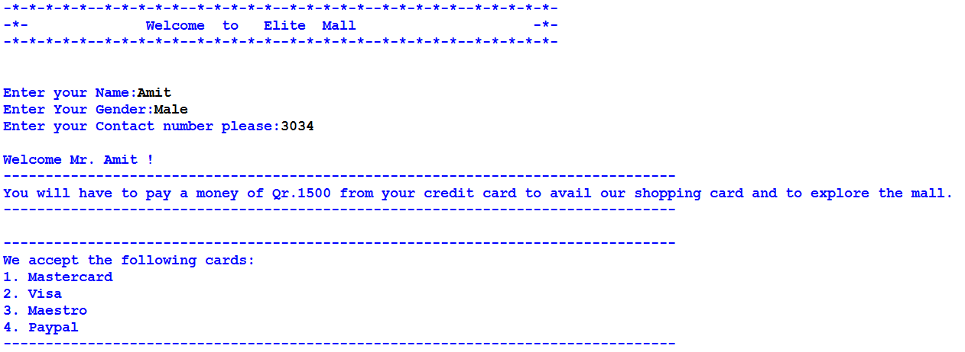

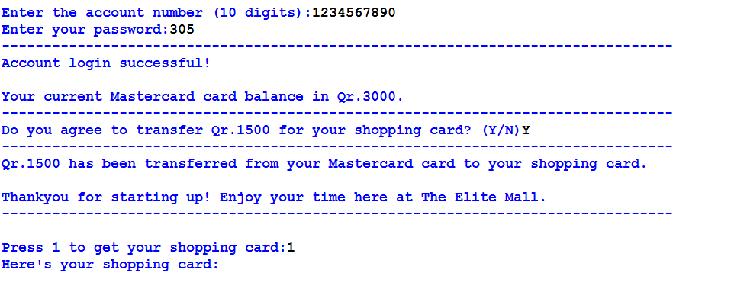

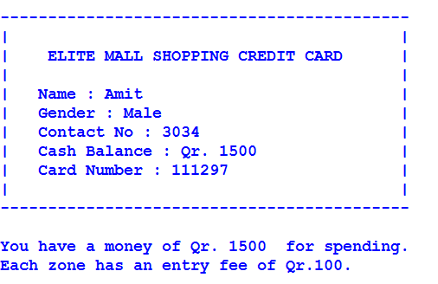

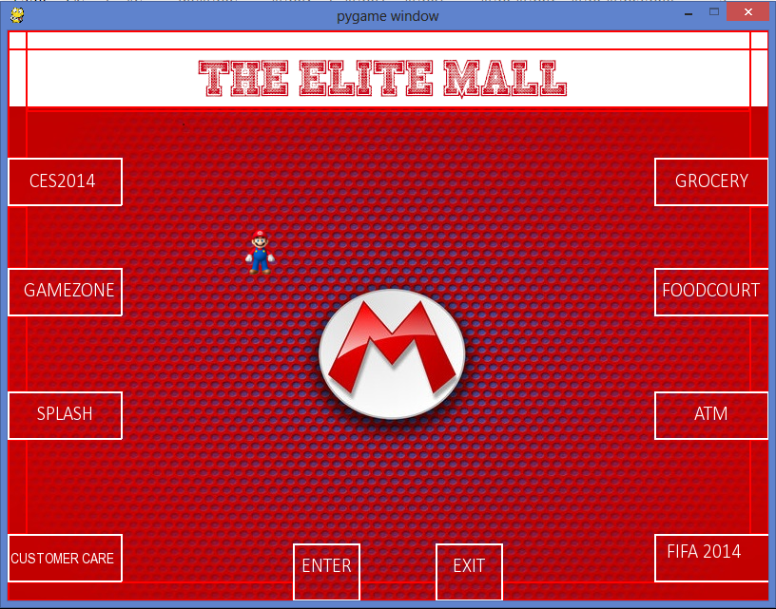

Grocery

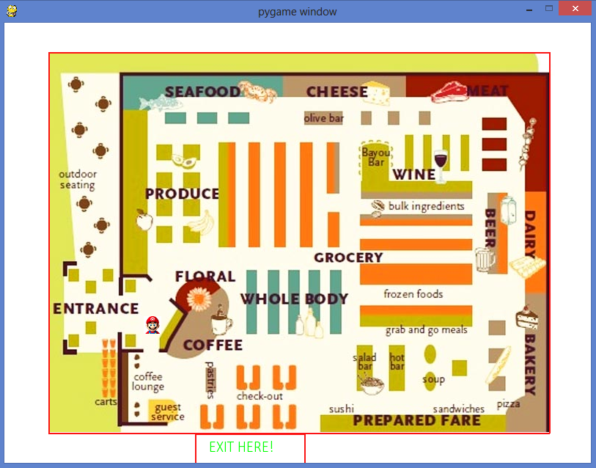

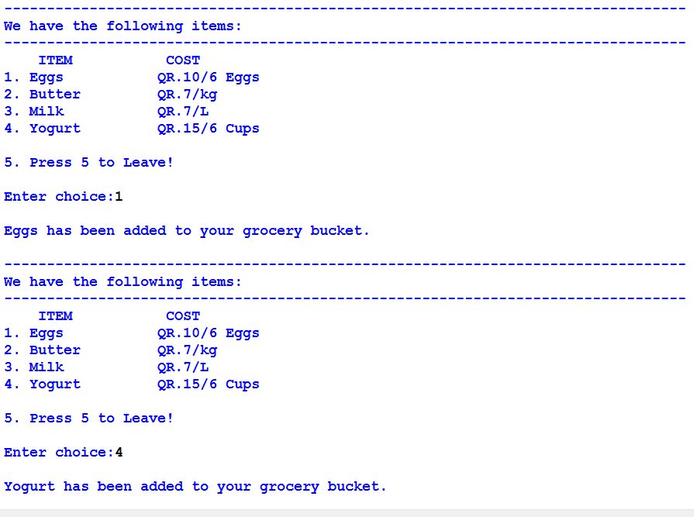

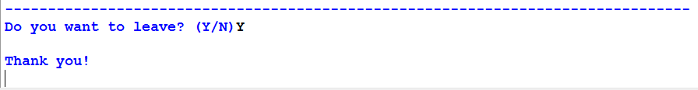

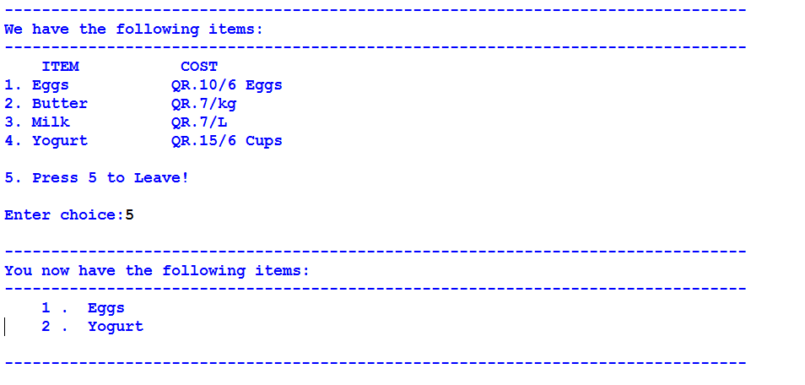

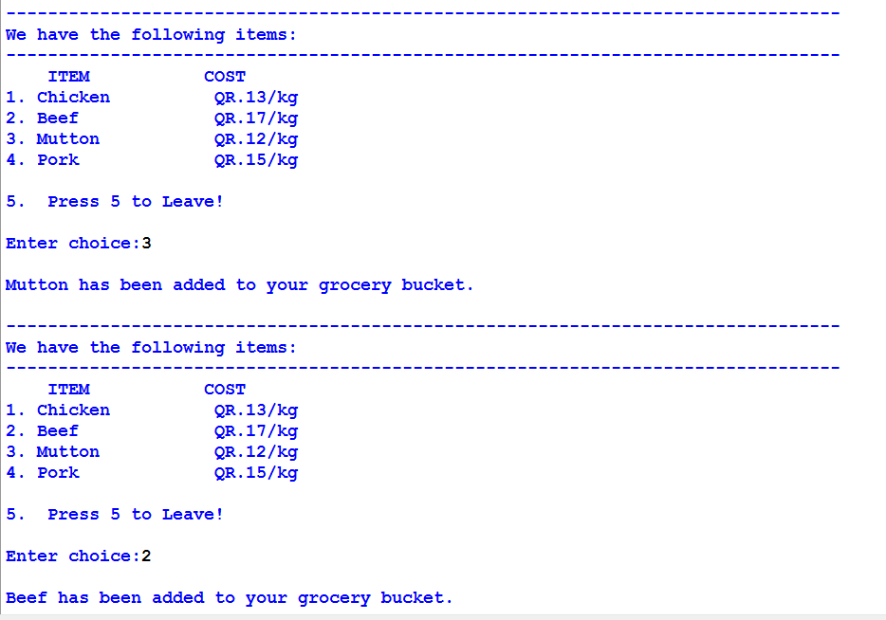

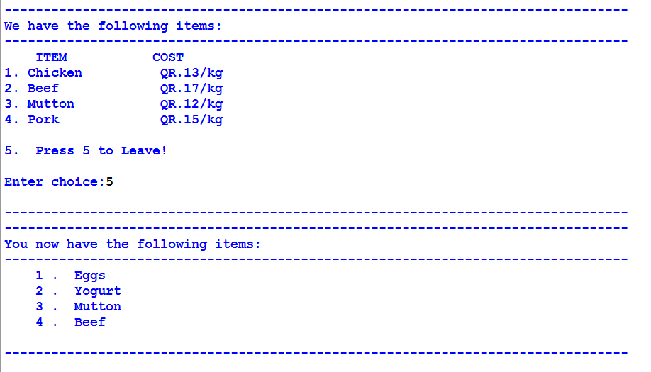

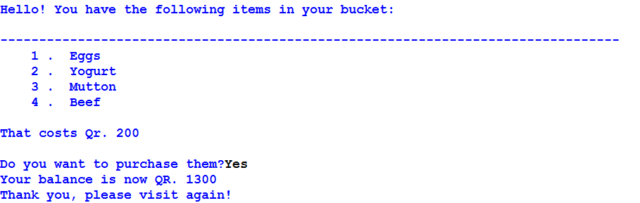

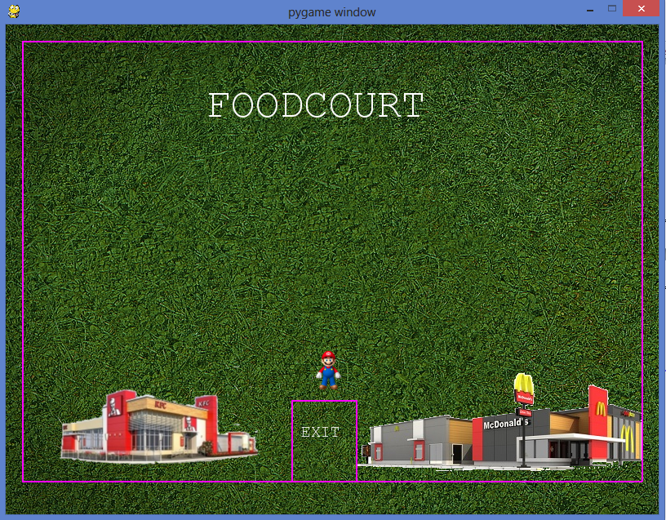

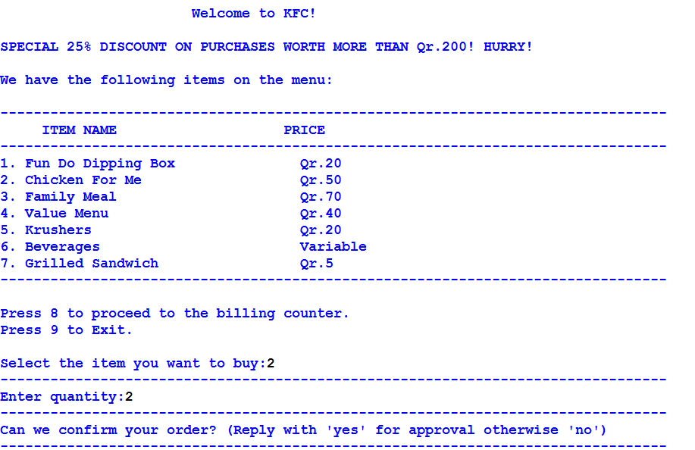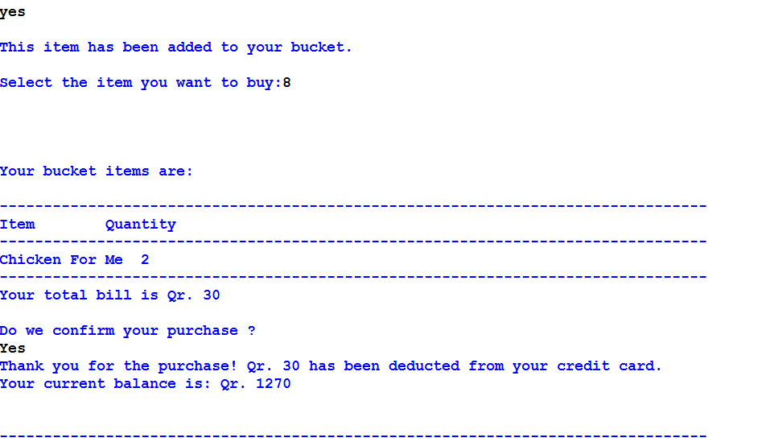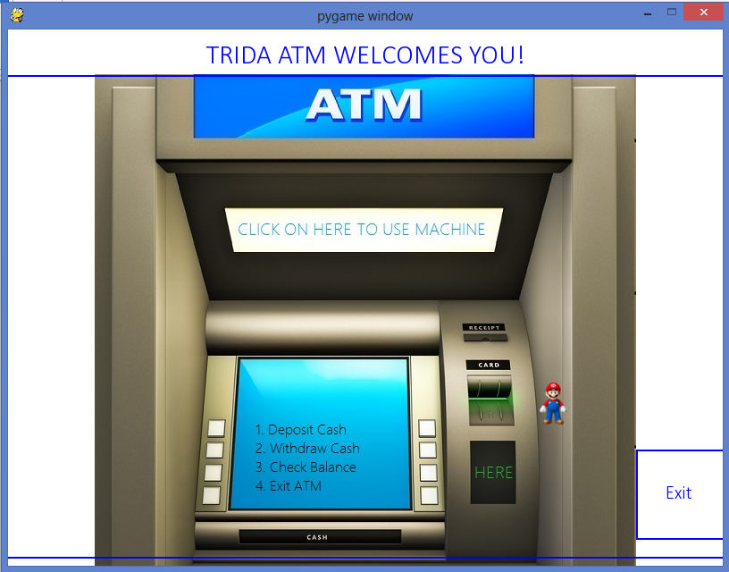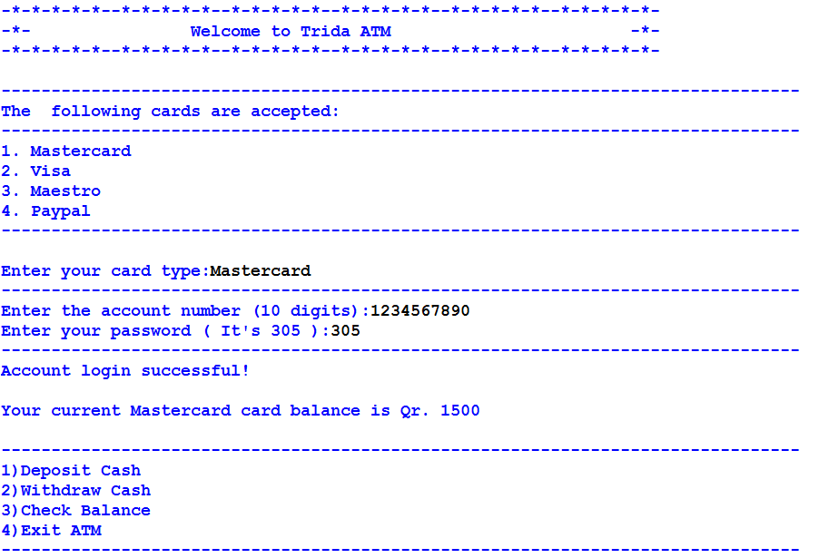

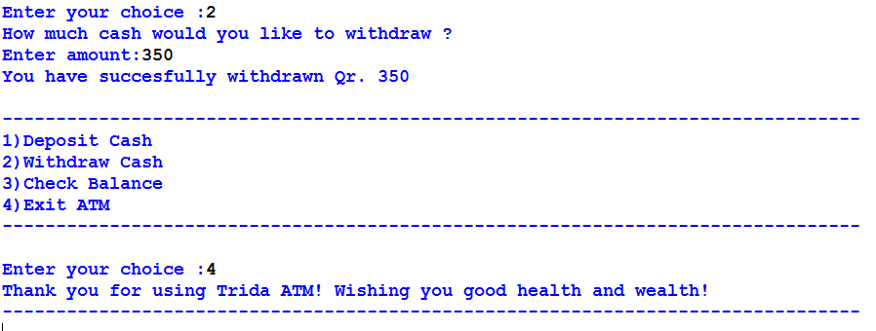

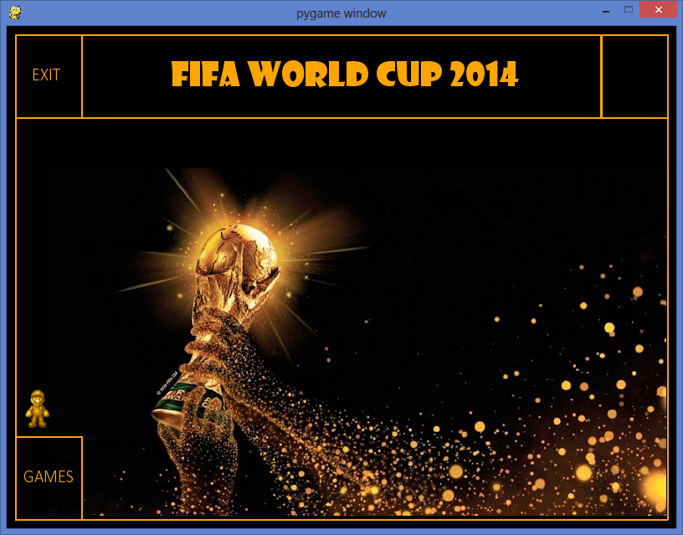

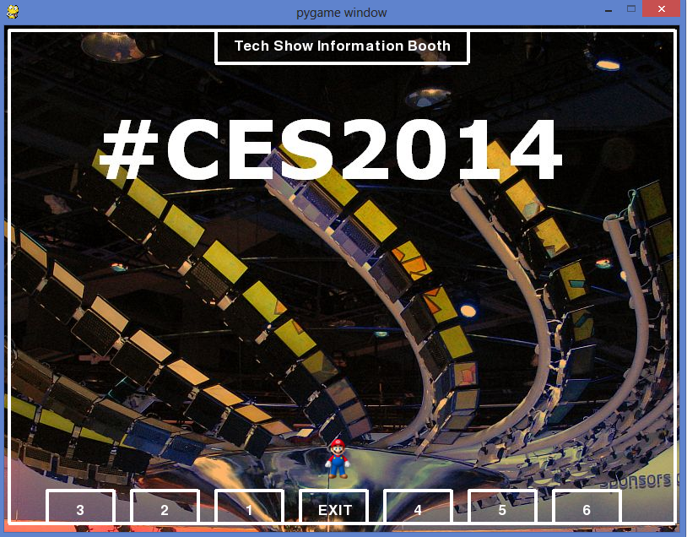

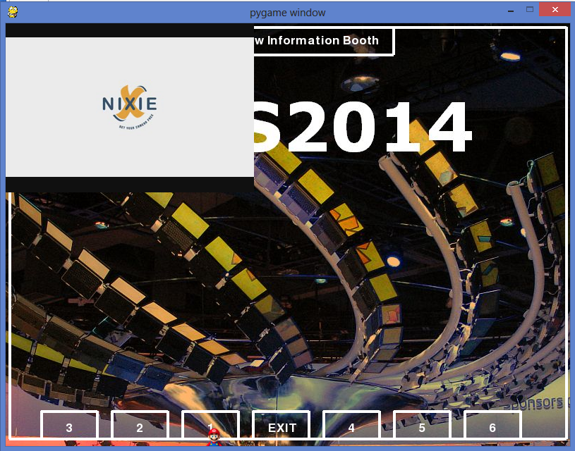

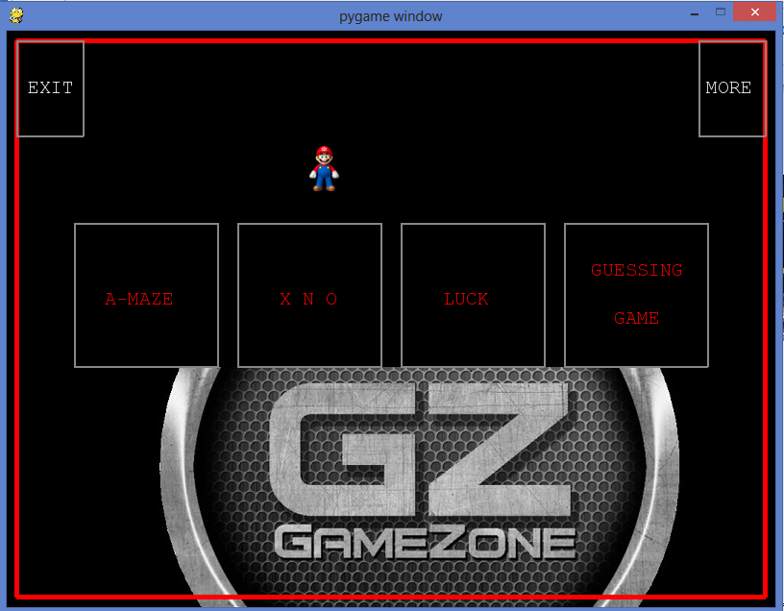

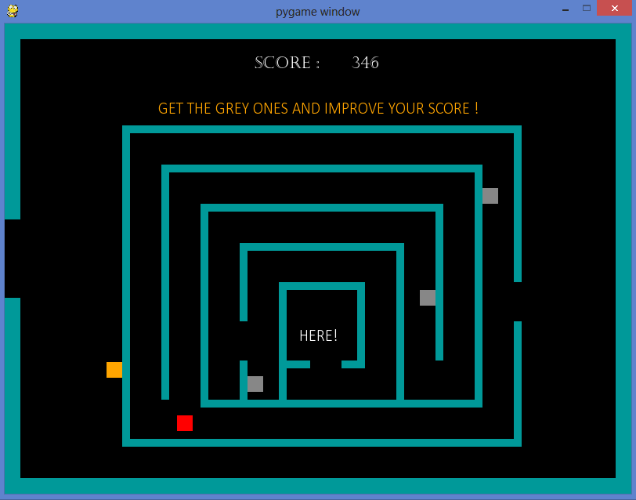

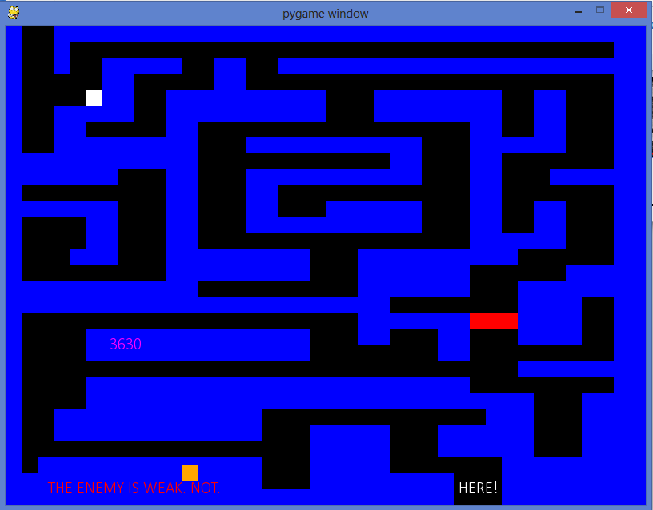

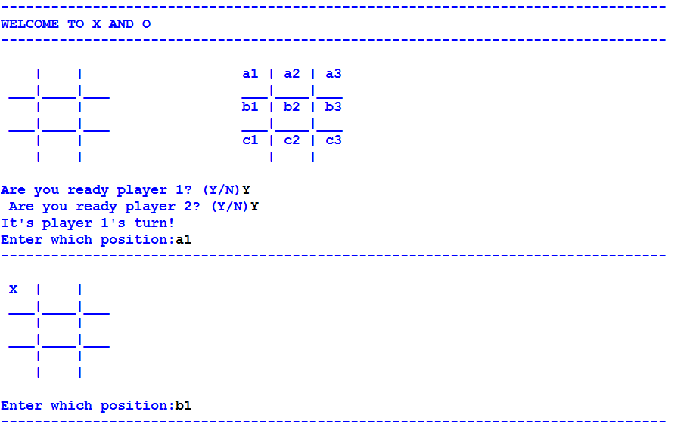

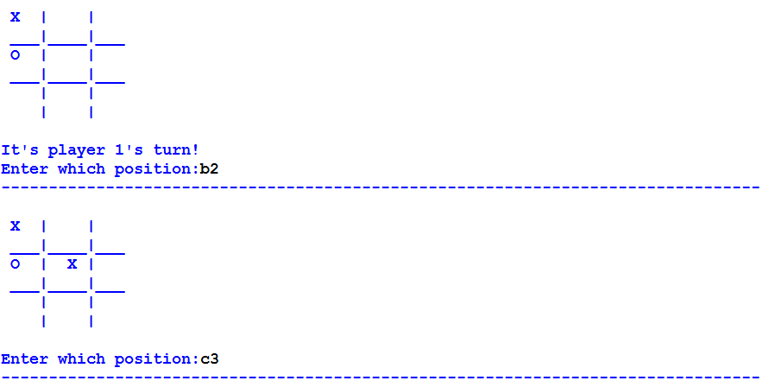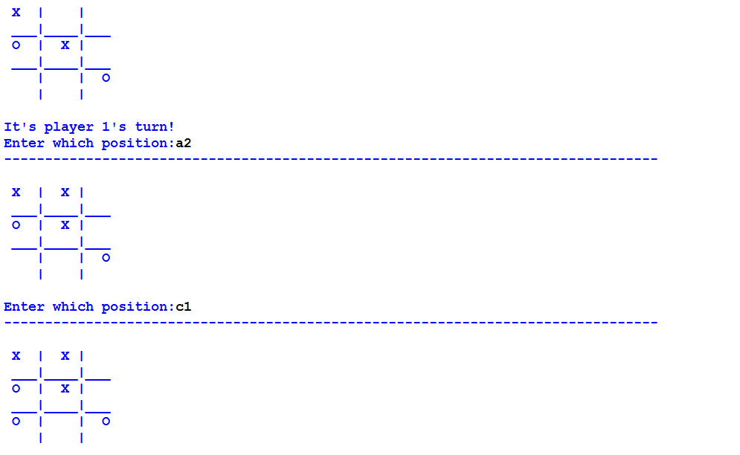

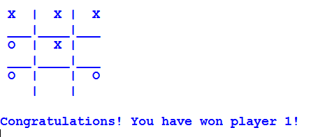

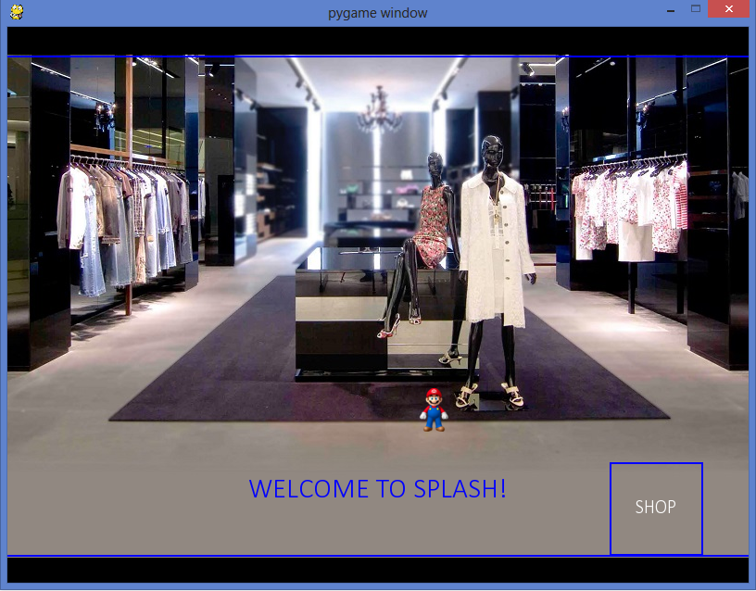

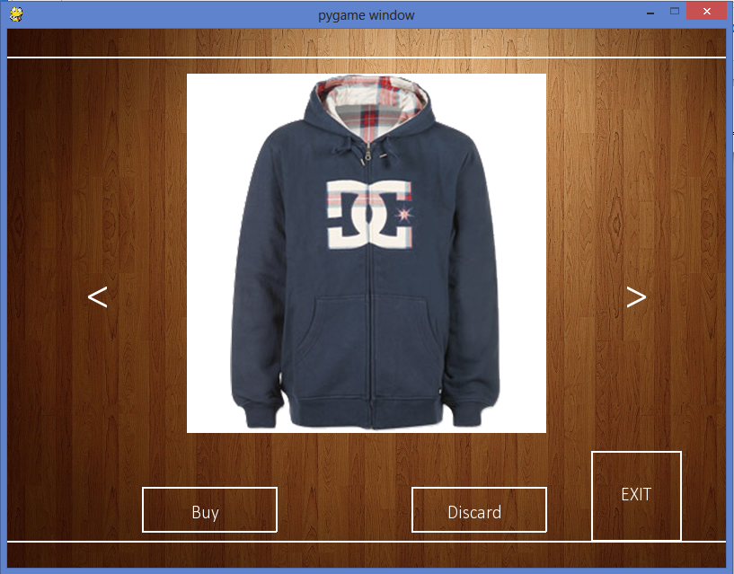

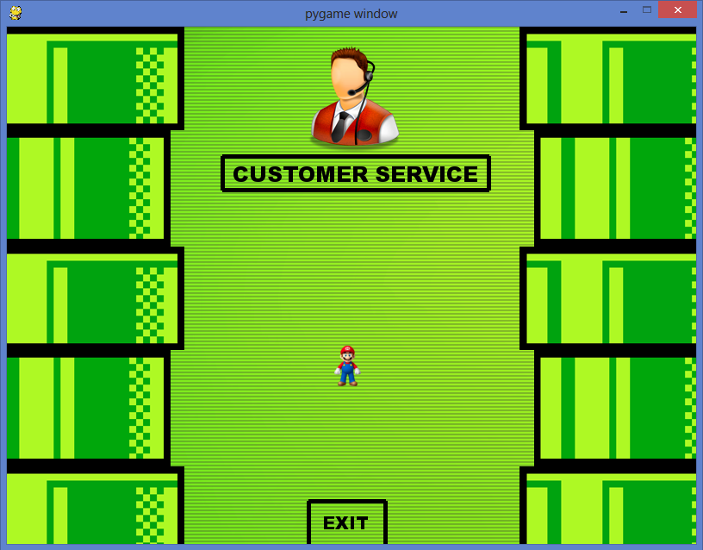

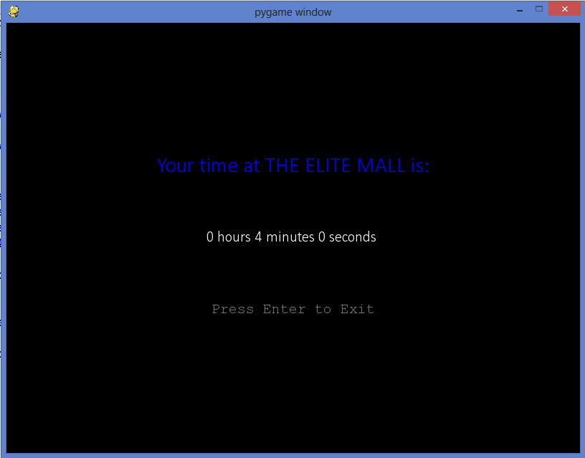

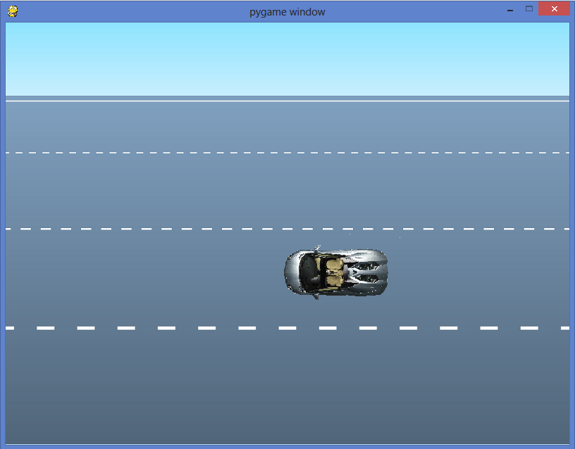

**SHORTCOMINGS**

**Some shortcomings of this project that can be improved upon are:**

* **The program does not accept a unique credit card password for each Guest.**
* **The ATM experience can be made more realistic.**
* **The customer service section does not provide feedback to the customer on the complaints lodged.**
* **Few more shops and systems like car parking mechanism can be added to the project.**

**BIBLIOGRAPHY**

* www.pygame.org
* [www.wikipedia.org](http://www.wikipedia.org)
* [www.programarcadegames.com](http://www.programarcadegames.com)
* [www.google.com](http://www.google.com)